

**Undergraduate design [thesis]**

**An Attention Network for Autism Diagnosis with Multi-modal Fusion Features Functional Connectivity**

Faculty: Electronic Information and Communication

Major Classes: Telecommunications 1901

Name: Yang Zongxian

Student Number: U201813398

Instructor: Prof. Yu Li

May 16, 2023

**Dissertation originality statement**

I solemnly declare that the thesis presented is the result of my research conducted independently under the guidance of my supervisor. Except for the contents cited in the text, this thesis does not include any other individual or collective published or authored works. I am fully aware that the legal consequences of this statement shall be borne by me.

Signature of the author

**Dissertation Copyright Use Authorization**

The author of this dissertation fully understands the regulations of the university concerning the protection and use of the dissertation, and agrees that the university retains and sends copies and electronic copies of the dissertation to the relevant dissertation administration departments or institutions, and allows the dissertation to be inspected and borrowed. I hereby authorize the Provincial Excellent Bachelor's Dissertation Selection Institution to compile all or part of this dissertation into the relevant data for searching, and I may use the reproduction means such as photocopying, microfilming or scanning to preserve and compile this dissertation.

This dissertation is classified as 1. Confidential Enclosure, and this authorization is applicable after the year of declassification.

2. No confidentiality Enclosure.

(Please tick the appropriate box above.)

Signature of the author

Signature of the supervisor

**Abstract**

Autism Spectrum Disorder (ASD) is a developmental disorder that affects an individual's social interaction, language communication skills, and behavioral patterns. It typically appears in early childhood and lasts a lifetime. Since the exact cause of autism is unclear, diagnosis mainly relies on the subjective assessment of clinical professionals, which is complex and requires high professional standards. Since the exact cause of autism is unclear, diagnosis mainly relies on the subjective assessment of clinical professionals, which is complex and requires high professional standards. In recent years, functional magnetic resonance imaging (fMRI), with its non-invasive, safe, and high-resolution advantages, has become a research focus and an important part of the research agenda. In recent years functional magnetic resonance imaging (fMRI), with its non-invasive, safe, and high-resolution advantages, has become a research focus and provides a new perspective for ASD diagnosis. This study uses a brain functional connectivity analysis method of resting-state functional magnetic resonance imaging to propose a multimodal feature fusion diagnostic strategy for ASD. First, a convolutional neural network (CNN) is used to diagnose ASD. convolutional neural network (CNN) based on spatial attention and channel attention mechanisms is designed to extract functional connectivity features of Eickhoff-Zilles. features of Eickhoff-Zilles (EZ), Harvard-Oxford (HO), and Automated Anatomical Labeling atlas (AAL) time series in the ABIDE database. Then, a discriminative module based on the self-contained feature fusion diagnostic strategy for ASD is designed. discriminative module based on the self-attention mechanism is designed to fuse and diagnose the three modal features. Through 5-fold cross-validation, the algorithm achieves the same results. validation, the algorithm achieves an average accuracy of 70.95%, sensitivity of 74.42%, and specificity of 69.15%, thereby realizing the automatic, efficient, and accurate diagnosis of autosis. Through 5-fold cross-validation the algorithm achieves an average accuracy of 70.95%, sensitivity of 74.42%, and specificity of 69.15%, thereby realizing the automatic, efficient, and accurate diagnosis of autism.

Key Words: CNN; Autism Diagnosis; Attention Mechanism; Functional Connectivity

**Catalogs**

**Abstract**  I

**1**  Introduction1

1.1 Background and significance of the study 1

1.2 Current state of research on autism diagnosis1

1.2.1 Traditional autism diagnosis2

1.2.2 Autism diagnosis based on facial information 2

1.2.3 Computerized autism diagnosis based on brain imaging data 3

1.3 Research topic selection and full text structure3

**2 Introduction to key techniques for fusing features to attentional classification models of functional brain connectivity in**  autism6

2.1 Resting-state functional MRI and functional brain connectivity analysis methods 6

2.1.1 Resting-state functional MRI6

2.1.2 rs-fMRI oriented approach to brain functional connectivity construction 7

2.2 Convolutional Neural Networks and Attention Mechanisms 9

2.2.1 Convolutional Neural Networks9

2.2.2 Attention mechanisms 11

2.3 Multimodal data fusion methods 13

2.4 Summary of the chapter 14

**3 Attentional categorization model of functional brain connectivity in autism with fusion**  features16

3.1 Feature extraction module based on channel attention and spatial attention 16

3.1.1 Lightweight fusion feature approach at the viewpoint level16

3.1.2 Feature Extraction Module Based on Channel Attention and Spatial Attention 17

3.2 Self-attention based feature fusion discrimination module 19

3.3 Summary 21

**4 Experimental results and**  analysis22

4.1 ABIDE data set 22

4.2 Training methods and evaluation indicators 23

4.3 Ablation experiments25

4.3.1 Predictive Performance of Viewpoint-Level Feature Fusion Strategies25

4.3.2 Predictive performance of channel-attention and spatial-attention based feature extraction modules 26

4.3.3 Predictive Performance of Self-Attention Based Feature Fusion Discriminant Module 28

4.4 Comparative experiments29

4.5 Summary of the chapter

**5 Summary and**  outlook31

5.1 Full text summary 31

5.2 Outlook 31

**Acknowledgement**  33

**Reference**  34

**1 Introduction**

**1.1 Background and significance of the study**

Autism spectrum disorder (ASD) is a common neurodevelopmental disorder, usually characterized by deficits in social communication and behavioral interactions. The exact cause of autism has not yet been fully elucidated, but research suggests that a variety of factors, including transmission, environmental factors, neurobiology, and the immune system, may be involved in the development of autism[1] . The diagnosis of autism is usually based on clinical assessments, behavioral observations, and home questionnaires. However, because the symptoms and severity of autism vary from person to person, traditional diagnostic methods often suffer from subjectivity and inaccuracy. Therefore, the development of a diagnostic method for autism based on objective data is of great clinical importance.

In addition, early diagnosis of autism is crucial to the treatment and rehabilitation of patients, and studies have shown that early diagnosis of autism with appropriate treatment and intervention can significantly improve the intelligence and communication ability of patients, which is very important for the reduction of symptoms and improvement of the prognosis[2] . At present, the most widely used autism diagnostic scale in China is the CARS scale compiled by American scholar E. Schopler in 1980. Although the measurement method is constantly updated over the years, the diagnostic method of this scale is still considered to have certain limitations and defects[3] , such as low validity for unsocialized individuals aged 0-6 years old, and a single sample of the scale, which is not able to meet the cross-cultural diagnosis, etc. Therefore, there is a need to develop a rapid and accurate diagnostic method that can be applied to the autism patients as soon as possible, and to provide them with appropriate treatments and interventions. Therefore, there is a need to develop automated diagnostic methods for autism that are rapid, accurate, and generalized for all age groups.

In recent years, deep learning has made significant advances in areas such as computer vision, natural language processing and medical image analysis, and as a result, the use of deep learning techniques to diagnose autism holds great promise. The use of deep learning can help increase knowledge and understanding of autism. In-depth study of brain functional connectivity and deep learning techniques in autism diagnosis can provide new ideas and directions for future autism research. Resting-state functional connectivity (rs-fMRI) data is a promising candidate for data-driven diagnosis[4] . In the past, a considerable number of studies have shown that autism is associated with abnormal brain connectivity[5][6][7] . Although the correlation between autism and brain connectivity has been confirmed, so far the academic community has not found a specific cause for the abnormality[8] . Therefore, this study aims to explore a fast and accurate autism diagnosis based on deep learning on the ABIDE (Autism Brain Imaging Data Exchange) database, which is a large-scale dataset of autism, by trying to merge multiple brain connectivity features, so as to provide clinicians with better diagnostic tools and decision support, and explore more possibilities for autism diagnosis based on brain functional connectivity. This will provide clinicians with better diagnostic tools and decision support, and explore more possibilities for autism diagnosis based on brain functional connectivity.[9] .

**1.2 Current state of research on autism diagnosis**

**1.2.1 Traditional autism diagnosis**

Currently, the DSM-V, a widely used clinical diagnosis of mental disorders, categorizes autism as a neurodevelopmental disorder and refers to it as Autism Spectrum Disorder (ASD). According to the DSM-V diagnostic criteria, a diagnosis of autism requires the fulfillment of the following two core areas of clinical manifestations[10][11] :

Social communication and interaction deficits: Specific clinical manifestations include a lack of nonverbal communication skills such as eye and body communication, which also manifests itself in limited use and understanding of these nonverbal communications; difficulties in establishing and maintaining social relationships, and a marked reduction or near absence of relative social interactions.

Repetitive and Restrictive Behavioral Patterns: Specific clinical manifestations include stereotypical and repetitive behaviors, or even pleasure, resulting in stereotypical patterns of thought, speech, and behavior; hypersensitivity or dependence on specific sensory stimuli, and therefore extreme sensitivity to environmental changes.

In contrast to other diagnostic methods, the DSM-V categorizes autism spectrum disorders as mild, moderate, and severe based on the severity of the clinical manifestations of an individual with autism. Currently, although there is no cure for autism, the social, language and learning abilities of people with autism can be significantly improved through early intervention and special education. Therefore, DSM-V also emphasizes the importance of early diagnosis and intervention of autism spectrum disorders, and targets some assessment tools and methods, such as M-CHAT and ADOS, which are used to help clinicians diagnose autism more accurately.

**1.2.2 Computerized autism diagnosis based on facial information**

Facial feature-based autism diagnosis is mainly based on the differences in facial features between ASD and typically developing children (TD), and the facial abnormalities of people with ASD in pictures or videos are automatically recognized by computers to assist in the early diagnosis of autism. Common methods include recognition based on facial expression, emotion, and eye movement data.

In the area of facial expressions and emotions, Joshua attempted to use an existing "DeepFACE" model[12][13] to automatically recognize the facial expressions of 12-month-old infants to determine if they are at risk for autism. The model was trained using a recurrent neural network and achieved an impressive 98.3% accuracy. Li built a binary diagnostic model based on a pre-trained CNN model using a publicly available dataset[14] , which used temporal feature extraction to extract the facial motion picture features of 105 children watching a video and built a binary diagnostic model using this dataset, which achieved sensitivities and specificities of 0.76 and 0.69, respectively. 0.69.

In the area of eye movement data, Chong utilized his clinical experience to invent an algorithm capable of parsing eye non-verbal interaction data data of children with autism and their guardians in their daily life interactions[15] . He captured a total of 22 hours of eye movement images from 100 children using a camera called the POV eye movement data collection camera as a dataset. An end-to-end deep learning framework (Pose-Implicit CNN) was developed to output diagnostic results based on the eye-contact characteristics of the samples in the input videos, with a model precision of 0.78 and a recall of 0.80, which significantly outperforms other diagnostic models based on eye movement data.

**1.2.3 Computerized autism diagnosis based on brain imaging data**

Autism diagnosis based on brain imaging data is mainly based on comparing and analyzing the brain imaging data of a large number of autistic and normal people to learn the characteristics of autism, so as to automatically diagnose new patients. Common imaging modalities such as structural magnetic resonance imaging (sMRI), electroencephalography (EEG), and functional magnetic resonance imaging (fMRI).

sMRI can provide fairly detailed information about brain structure, helping to localize areas of abnormality more accurately, and thus has performed well in studies of the pathology of autism. in 2017, Hazlett's study published in Nature performed early detection of autism through biometrics in structural magnetic resonance imaging[16] . The researchers obtained biological features such as neural connection strength, neuronal density and brain region activity levels from sMRI data of a sample of 148 infants between 6 and 12 months of age, and combined them with then-emerging deep-learning networks to construct a model for the early diagnosis of autism. The modified model achieved 81% sensitivity and 88% specificity for the first time in the field of deep learning-based brain imaging for autism diagnosis, successfully demonstrating the feasibility of using brain imaging data for autism diagnosis. Compared to MRI impact, EEG facilitates routine clinical diagnosis with its lower cost while being compatible with rich temporal resolution. alisa successfully achieved 79% ASD diagnostic accuracy by performing pattern recognition analysis on the brain signal database, filtering out features and differentiating them using a multilayer perceptual machine network[17] . fMRI is non-invasive, reproducible, and high-resolution, can access brain activity patterns and functional brain networks, and thus outperforms other brain imaging methods in terms of theoretical accuracy of diagnosis. emerson used 59 6-month-old samples, from which features were extracted from their resting-state functional MRI (rs-fMRI) data[18] , and built an SVM classification model labeled with the sample's diagnosis of autism at the age of two. The model demonstrated 81.8% diagnostic sensitivity and 100% diagnostic specificity. Wenhui Li used the AAL-90 template to analyze the ROI time-series information of the ABIDE database, and considering the limited nature of the ABIDE database, he proposed a sliding time window data enhancement method to expand the amount of data from 871 to 5779, and trained the ViT-B/16 model accordingly, and finally without setting up a test set, the ten-fold cross validation achieved a 74.18% correct rate[19] .

**1.3 Research topic selection and full text structure**

Small sample size and single modality selection are problems in most of today's functional connectivity-based autism diagnostic research results[20] . It should be noted that in most of the studies based on the ABIDE database, the diagnostic methods proposed in the studies tend to be very effective when the number of data used is small and the sites are relatively homogeneous, but the diagnostic accuracy and sensitivity of the models are significantly reduced once we enter into the task of multi-site and large data volume. This study attempts to solve the above problems by using a multimodal, fused feature approach. The main research work of this paper includes:

First, a lightweight fusion feature approach is designed to combine the three ROI information of aal, ez, and ho in a lightweight way, which significantly improves the diagnostic recall of the model.

Second, the lightweight ROI feature extraction module is constructed to add the channel attention mechanism and spatial attention mechanism to the traditional CNN feature extraction method, which extracts the features of different ROI correlation matrices into 128-dimensional feature vectors to be delivered to the feature fusion discrimination module, and significantly improves the specificity of the model.

Third, the self-attention-based feature fusion module is constructed, and after receiving the correlation matrix features with different ROIs, the self-attention module is used to assign the weights of different features, which significantly improves the diagnostic accuracy of the model.

The full text is organized as shown in Figure 1-1: Chapter 1 introduces the background and significance of autism research, describes the need for clinical diagnosis of autism and the limitations of traditional diagnostic methods. The importance and prospects of using deep learning techniques for autism diagnosis are emphasized. This chapter also describes the clinical significance and urgent need for early diagnosis of autism from the perspectives of patients and physicians. Then, focusing on the current research status of autism diagnosis, computerized autism diagnosis modalities based on facial information and computerized autism diagnosis modalities based on brain imaging data are introduced in detail, and the advantages and disadvantages of the existing methods are analyzed. The importance of computer-assisted diagnosis and the use of multimodal data is highlighted, and this leads to the research method and work of this paper.

Chapter 2 outlines the key techniques in deep learning-based attentional classification modeling of functional brain connectivity in autism. First, the basic concepts of rs-fMRI data and its importance in autism diagnosis are briefly introduced. Then, the application of brain functional connectivity analysis methods in autism diagnosis is described in detail. Then the model architecture of convolutional neural network (CNN) within the field of deep learning and the specific operation process of the attention mechanism are elaborated. In the final section, we detail strategies for fusing multimodal data in order to provide theoretical and technical aspects for future chapters.

Chapter 3 describes in detail the fused features designed in this paper for an attention classification model of functional brain connectivity in autism, which is the main work of this study. First, the lightweight fusion feature approach designed in this paper that can significantly improve the model recall is introduced. Next, the lightweight ROI feature extraction module that fuses two attentional mechanisms is presented, which successfully improves the specificity of the model by using channel attention. Finally, the feature fusion module based on self-attention is introduced, which successfully improves the diagnostic accuracy of the model by using the self-attention module to assign the weights of different features after receiving the correlation matrix features with different ROIs.

Chapter 4 focuses on the experimental details, experimental results and experimental analysis. The dataset and data preprocessing methods used in this paper are first introduced. Then the hyper-parameter settings of the training model and the indexes for evaluating the classification effect of the model are introduced. Finally, the experimental results of the ablation experiment and the comparison experiment are shown, the role of each module is analyzed, and the effectiveness of the method of this paper is verified by data comparison.

Chapter 5 summarizes the full text and briefly describes future research directions and perspectives on functional connectivity-based autism diagnosis.

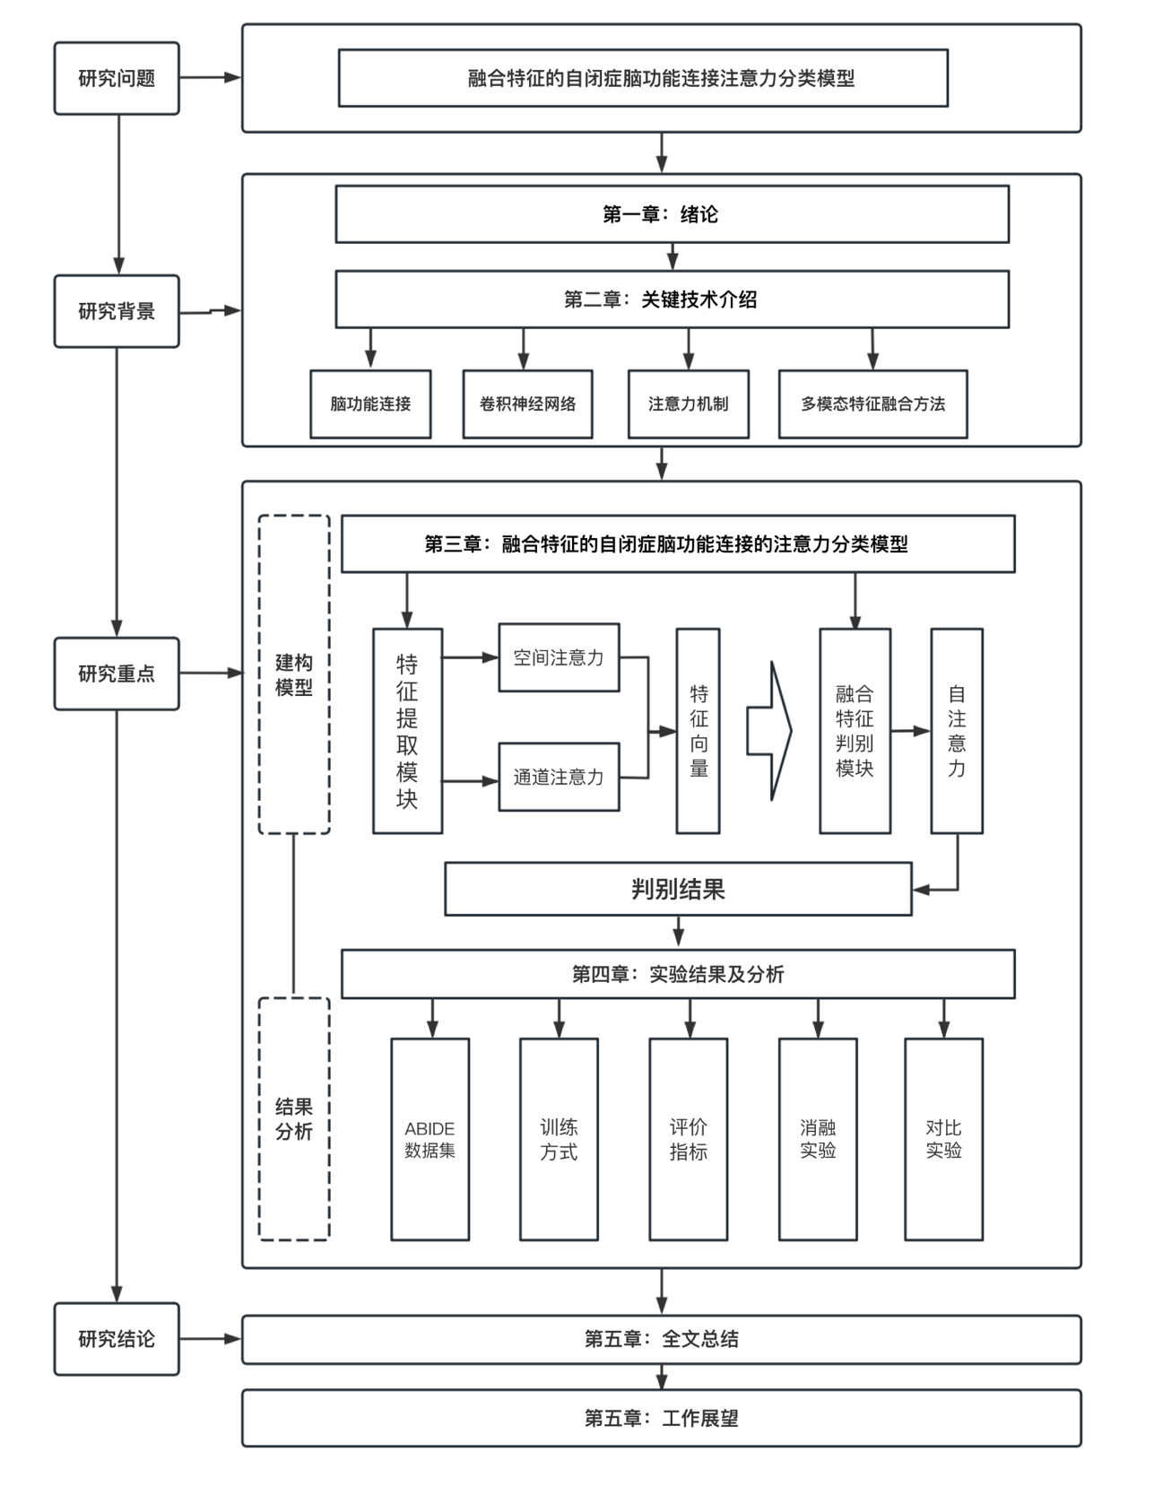

Figure 1 -1 Structure of the full text

**2 Introduction to the key techniques of functional brain connectivity attention classification model for autism with fusion features**

Autism is a complex neurodevelopmental disorder whose etiology and pathogenesis are not yet fully understood. In recent years, with the continuous development of functional magnetic resonance imaging (rs-fMRI) technology, researchers have extensively studied the functional brain connectivity of autistic patients. Functional brain connectivity describes the interactions and synergistic activities between different regions of the brain, which is valuable for revealing the pathophysiological mechanisms of autism. However, traditional methods for analyzing brain functional connectivity are usually based on low-dimensional features, making it difficult to fully reveal the complex information of the brains of autism patients. In order to fully explore the high-dimensional features of patients' brain functional connectivity, deep learning techniques, especially convolutional neural networks (CNNs) and attention mechanisms, provide effective tools for autism diagnosis and research.

In autism diagnosis and research, the limitations of unimodal data have gradually come to the forefront, especially in the case of a large amount of data, which makes it difficult to achieve the desired results. The comprehensive utilization of multimodal techniques is gradually becoming a trend in deep learning-based autism diagnosis. By integrating information from different data sources, multimodal data fusion is expected to provide a more comprehensive basis for autism diagnosis and research. In this chapter, we will introduce in detail the key techniques for fusing features of the brain functional connectivity attention classification model for autism from rs-fMRI and brain functional connectivity analysis methods, convolutional neural networks and attention mechanisms, and multimodal data fusion methods. We will deeply analyze the principles and applications of these techniques, explore how to overcome the limitations of unimodal data, and lay a solid foundation for subsequent research work.

**2.1 Resting-state functional MRI and functional brain connectivity analysis methods**

**2.1.1 Resting-state functional MRI**

At present, fMRI technology has gradually developed into one of the main ways for human beings to deeply understand the function of the brain. Its main working principle is to detect the magnetic resonance signals caused by changes in blood oxygen levels as a way to reveal the activity state of various regions of the brain, and this method is called BOLD-fMRI[21][22] . In practical applications, there are two main forms of fMRI: the first one is fMRI in the task state, i.e., the participant is required to perform a specific task during the data collection process, such as opening and closing the eyes, moving the fingers, or viewing pictures, etc. The second form is resting-state fMRI (rs-fMRI), in which the participant only needs to lie down quietly, relax his/her whole body, and keep his/her mind clear without being affected by any external stimuli during the rs-fMRI[23] examination.

rs-fMRI mainly reflects the spontaneous neural activity of the brain. Studies have shown that the human brain, which accounts for only 2% of the total body weight of a human being, has a staggering 20% resting state energy consumption ratio[24] . As shown in Figure 2-1, the black shading represents the proportion of energy consumption in each body part in the resting state, which shows that the proportion of energy consumption in the brain is extremely high, indicating that the brain is still performing complex activities even in the resting state. In addition, compared with task-state fMRI, rs-fMRI does not require researchers to have a strong psychological background, which is especially suitable for experiments on patients with mental illness. In addition, the experimental approach of task-state fMRI varies depending on the research institution, which makes the cross-institutional data more varied and more difficult to integrate into large-sample data, and thus is not conducive to the study of machine learning methods that require larger samples of data. Therefore, rs-fMRI data are widely used in the field of machine learning.

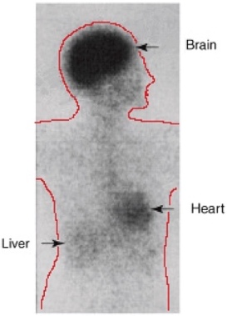

Figure 2 -1- Energy consumption diagram of major body parts in resting state

**2.1.2 rs-fMRI oriented brain functional connectivity construction methods**

The brain is a sophisticated networked system with billions of neurons and trillions of neural connections, handling a wide range of complex tasks with amazing responsiveness. In the early stages of brain science, researchers assumed that brain functions were separate from each other - for example, listening and speaking are performed independently by two completely different brain regions - and were therefore mainly limited to brain region activation studies exploring specific brain tasks. Subsequent research, however, has shown that this simple decomposition of functions may be incomplete, and that the brain may perceive and respond to changes in the environment through more complex network patterns, using a parallel approach of decomposition and integration. Brain Connectivity is the topological network of the brain formed by the joint operation of multiple functional brain regions[25] . Friston et al. introduced this concept into the field of functional imaging research in the early 1990s and subdivided it into Structural Connectivity, Functional Connectivity (FC) and Functional Connectivity (FCC). Functional Connectivity (FC)[26] and Effective Connectivity.) Among them, functional connectivity mainly refers to neuronal activities that are spatially separated but show correlation in time series, which reflects the way different brain regions collaborate in the execution of a certain brain function. By assessing the correlation or covariance of neuronal activities, we can obtain a large amount of information reflecting the state of brain activity. As shown in Figure 2-2, where is a brain region, each element in the matrix represents the strength of functional connectivity between the brain region and the brain region .

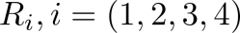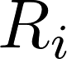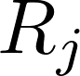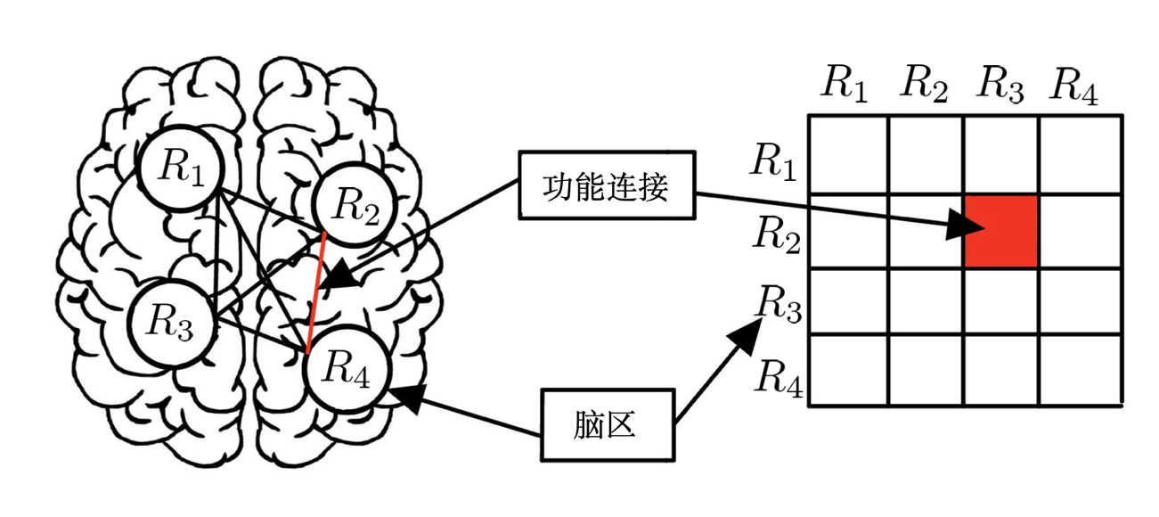

Figure 2-2 Schematic diagram of the division of brain functional connectivity

In brain functional connectivity analysis, researchers often study the association between different brain regions by analyzing the functional activities between them. The Pearson Correlation Coefficient (PCC) is a commonly used statistical method to measure the degree of linear correlation between two variables, and is therefore also used to construct brain functional connectivity based on fMRI data. It can be used to measure the degree of similarity between the functional activities of two brain regions over a time series. Specifically, it calculates the linear correlation between two time series, reflecting the degree of their similarity in terms of change trends, as shown in the following formula:

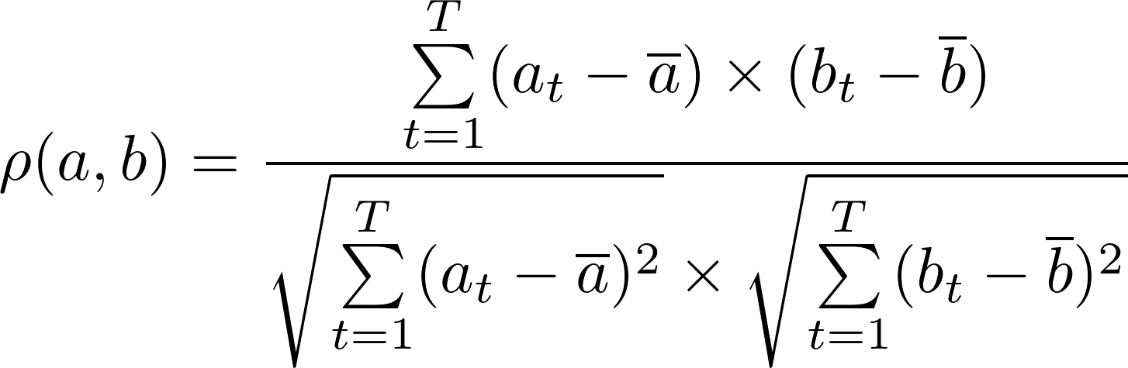

Among them, the BOLD signals of brain region and brain region are represented by and , respectively, with a total number of time points of T. and represent the average activation of brain region and brain region . In addition, , when , indicates that the two brain regions are negatively correlated activation; when , indicates that the two brain regions are not functionally interacting; and when , indicates that the two brain regions are positively correlated activation. Thus the size of represents the strength of functional interaction between two brain regions. The brain functional connectivity matrix constructed by this method is strictly symmetric along the diagonal, with each row (column) representing a brain region, and the elements in the matrix representing the strength of functional connectivity between the corresponding two brain regions.

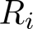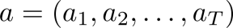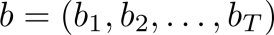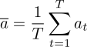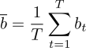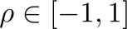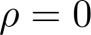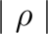

The human brain is a very complex structure, and whole-brain fMRI data can typically contain hundreds of thousands of voxels, each representing a BOLD signal with complex temporal signals. Attempts to construct brain functional connectivity from whole-brain fMRI data would result in a functional connectivity matrix with hundreds of millions of features that would be difficult to process. For this reason, it is common in the research field to use predefined templates for the delineation of regions of interest (ROIs) and to use the mean value of the voxel BOLD signals within the ROIs as the BOLD signals representing the ROIs. This approach allows for a significant reduction in the number of features, making the analysis possible.

In 2005, Salvador and his team pioneered the Whole Brain Functional Connectivity (WBFC) analysis method, which is based on correlation analysis and calculates the functional connectivity (FC) of the whole brain to gain insights into brain activity patterns[28] . The process is as follows: First, the whole brain is divided into thousands of regions using standard brain templates such as the AAL template. Then, the average BOLD time series of each region is extracted, which is an important signal reflecting the activity of brain regions. Next, the Pearson's correlation coefficient between the time series of any two brain regions was computed as a way to obtain the FC between any two brain regions.Eventually, they obtained a whole-brain FC network, which is usually presented in the form of a matrix. It is worth mentioning that the AAL (Automated Anatomical Labeling) template[29] , also known as Automated Anatomical Labeling template, is a commonly used tool for brain region segmentation. It is based on an advanced neuroanatomical atlas that is capable of segmenting the human brain into 116 brain regions, including the cerebral cortex, basal ganglia, brainstem, cerebellum, and other parts. The Easiness Zone (EZ) template and the Harvard-Oxford (HO) template are two other predefined templates commonly used in neuroscience research[30] . The EZ template is based on the concept of easiness zones in the human brain, and its main purpose is to depict those brain regions that show higher variability in the general population. These brain regions may exhibit different activation patterns when dealing with specific tasks, and thus the use of EZ templates may help to capture information specific to these regions when constructing functional connectivity matrices. The Harvard Oxford template (HO), on the other hand, was developed by Harvard University and the University of Oxford, and consists of a meticulous delineation of the cortical and subcortical structures of the brain.The HO template is an anatomically based template that provides a very fine-grained delineation of the brain in terms of 48 cortical and 21 subcortical regions. When using the HO template, researchers can get more precise ROI delineation results, which helps to understand the functional connectivity properties of the brain more deeply.

**2.2 Convolutional Neural Networks and Attention Mechanisms**

**2.2.1 Convolutional Neural Networks**

Convolutional neural networks (CNNs) are iconic networks in deep learning to handle the transformation between layers with their convolution operation for forward propagation[31] . Compared with fully connected neural networks, each neuron in a CNN is connected to only some of the neurons in the previous hidden layer, and this sparse connectivity and parameter sharing effectively reduces the number of parameters and computation in CNNs.

In general, CNNs contain three main operations: convolution (Conv), pooling, and Fully Connection (FC). As shown in Figure 2-3, the convolution step is responsible for extracting information from the input data and performing layer-by-layer convolution operations on the features of the neural network through convolution kernels. Each convolution kernel contains a weight and bias that can be autonomously varied by back propagation to capture the information of each region in the form of a sliding window, thus realizing the feature extraction of each region of the input image. When processing color images, each convolution kernel corresponds to one channel, multiple channels correspond to the same location, and finally the inner product results of each convolution kernel are aggregated to compute the feature map. In addition to convolutional operations, CNN also nonlinearly maps the convolutional features of each layer through activation functions to enhance the performance of the whole network. This design avoids problems such as vanishing gradients caused by linear mapping. Common activation functions include sigmoid, tanh and ReLU.

After the features have been mapped to a nonlinear space by an activation function, feature selection can be performed by pooling operation. Pooling operations are used to solve the feature redundancy problem by reducing the size of the output in order to achieve the downscaling of the features. Common pooling operations mainly include maximum pooling and average pooling. Maximum pooling samples the maximum value of local features to obtain the most important information, while average pooling samples the average value of local features to preserve the overall features and background information. The fully connected layer is located in the final stage of the neural network, which aggregates and unfolds all the features for subsequent classification or prediction. Completely different in function from convolution and pooling operations, the main task of the fully connected layer is to map the convolved features to the category space, corresponding to the number of categories one by one, so as to realize the classification function. Overall, CNN performs deep feature extraction and classification prediction on the input data through convolution, pooling and fully connected operations.

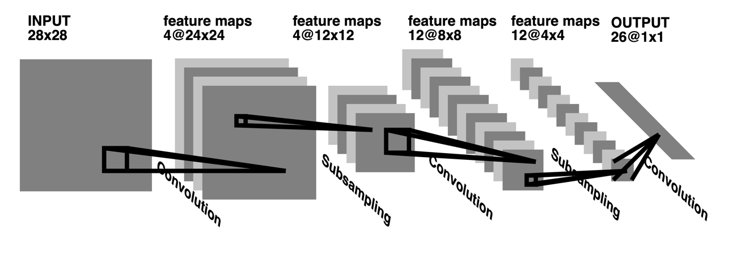

Figure 2-3 Convolutional neural network for image processing[32]

With the advancement of deep learning, the infrastructure of CNNs has been continuously improved and optimized. In the last century, Yann LeCun et al. proposed the LeNet-5 model, which is a method for training neural networks using the Backpropagation (BP) algorithm[33] . However, this early CNN model did not perform as well as it should have, the network was very difficult to train and was not as effective as traditional machine learning algorithms such as Support Vector Machines (SVM) and Boosting. However, the situation changed in the ImageNet competition, where AlexNet, proposed by Geoffrey Hinton and others, succeeded in designing a deeper network structure, opening the door for the application of CNNs in the field of deep learning[34] . Since then, a series of excellent CNN backbone networks have been proposed, such as VGGNet[35] , ResNet[36] and Inception[37] , which further promote the development of CNN in the field of image classification. These advanced network architectures not only deepen the network structure, but also introduce new techniques and ideas, such as residual connectivity, depth separable convolution, etc., which greatly improve the performance and efficiency of the model.

**2.2.2 Attention mechanisms**

The human visual system, through its unique attentional mechanism, is able to selectively focus on and capture salient information in complex scenes without the need to comprehensively process all the information in the entire scene. This is mainly attributed to the inherent limitations of the human visual nerve's ability to process image information. Guided by the attentional mechanism, one can direct primary attention to those information-rich, critical parts of the scene, while ignoring those less informative or relatively irrelevant regions. Inspired by this mechanism, researchers have tried to introduce the attention mechanism into neural networks, so that the networks can process image information in the same way as the human visual system, focusing on the critical parts of complex images and filtering out redundant or useless information. Such processing allows neural networks to be more effective and accurate in tasks such as image recognition and feature extraction. The core idea of the application of the visual attention mechanism in the field of deep learning is to mine and utilize the structural associations within the data to highlight and extract key features.

The spatial attention mechanism helps the neural network to select the appropriate target spatial region for scale transformation. In order to simplify the classification process and improve the classification performance, spatial attention uses different spatial transformations to transform the information in the image from the original space to another space[38] . For example, as shown in Figures 2-4, the spatial attention mechanism generates a transformation parameter θ by spatially adapting the input U through a local network, and then, based on this transformation parameter θ, the mesh generator performs a corresponding affine transformation on the input. In the final stage, the sampler carries out the generation of the corresponding feature map V, which realizes the weighting of spatial attention. The model can change the attentional weights during the training process of backpropagation to find out the regions in the image and space that need attention.

Channel Attention expects channel modeling to uncover relevant dependencies in the convolutional channels in order to make channel-by-channel adjustments to features. In this way, the network is able to improve its representational capabilities by using global information to weight the importance of key features while always irrelevant features. In layman's terms, this approach attempts to discover potential correlations between individual convolutional channels and exploit such correlations for feature selection and tuning, thereby optimizing the performance of the network.

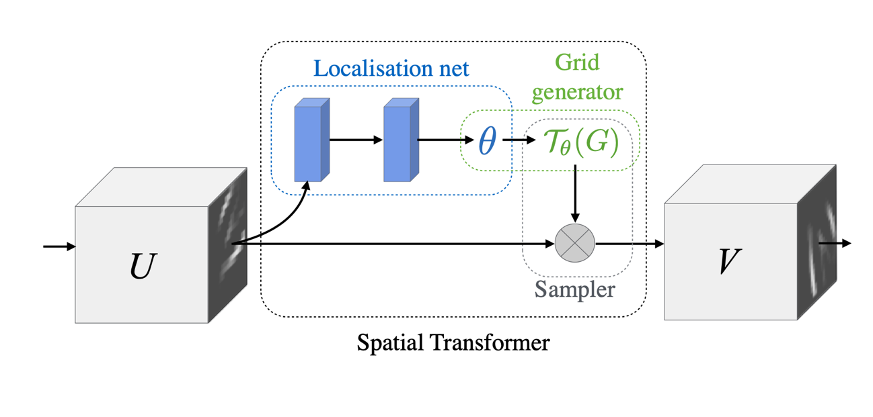

Figure 2-4 Spatial Attention Module[38]

A typical example is the Squeeze-and-Excitation Block (SE-Block)[39] , as demonstrated in Figure 2-5, where the SE-Block initially compresses the input feature map while retaining the same number of channels, and uses the global spatial features of each channel as a representative of that channel. These representatives are then used to perform excitation operations that train dependencies on the individual feature channels and adaptively weight the calibration of the feature channels according to the dependencies.The elegance of SE-Block lies in its ability to build the network in a stacked fashion, so it can be easily added to an existing network. In shallow networks, SE-Block improves the quality of shallow representations in a class-independent manner, whereas in deeper networks, SE-Block becomes increasingly class-dependent, so that the gain of SE-Block calibration features can be accumulated throughout the network.

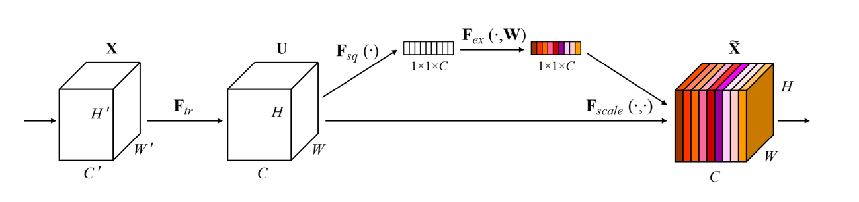

Figure 2-5 Channel Attention Mechanism[39]

Self-attention, on the other hand, is an attentional mechanism that is able to learn the relationship between a pixel point and all other pixel points, denoting the degree of prominence of a pixel point over other pixels, and therefore capturing the relationship between various local long distances in an image. The ability to utilize relative positional features to help generate a detailed part of an image, thus highlighting this positional feature to make it effective is the most significant advantage of the self-attention mechanism. This focus on details and specific locations gives the self-attention mechanism a significant advantage when dealing with complex images or scenes, capturing subtle differences that may be overlooked by the human eye. As shown in Figure 2-6 During the training process, the input features are extracted directly through a 1x1 convolutional layer for each pixel point. The key to this process is that the parameters of the convolutional layer are initialized to 0 during the initial stage of training, meaning that the network relies primarily on features from neighboring pixel points at the beginning. Then, as training proceeds, the network gradually increases the weights of the dependence on regions far away from it, thus better modeling the relationship between different regions of the image. This strategy overcomes the problem of traditional Convolutional Neural Networks (CNNs) where the characterization ability is limited to the neighboring regions and effectively highlights the contribution of other regions of the globe (e.g., distant pixel points) to the current region.

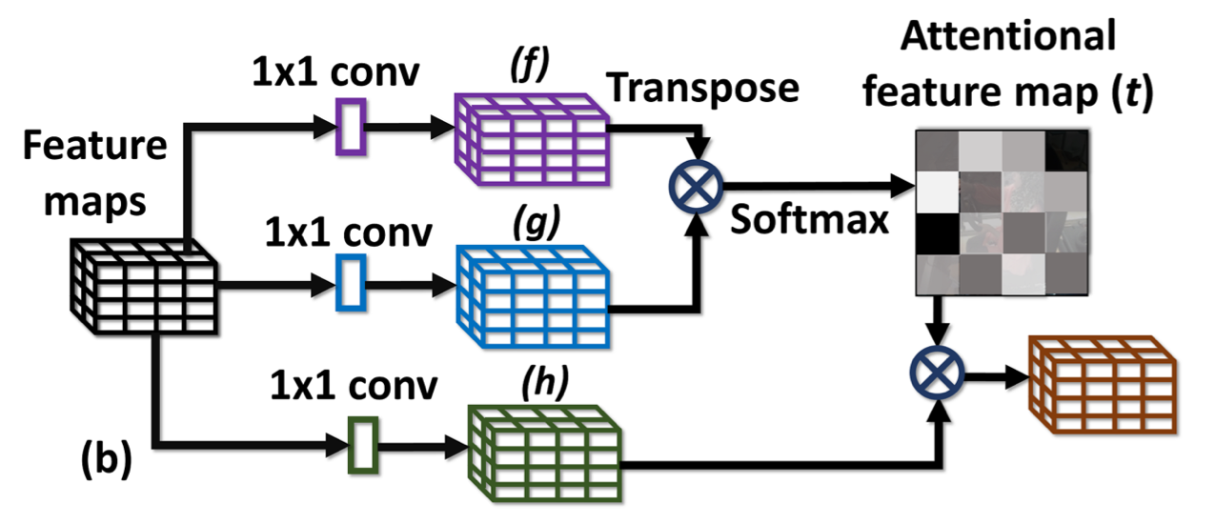

Figure 2-6 Self-attention mechanism[55]

Overall, the attention mechanism, with its unique advantages, provides deep learning models with a new and more comprehensive perspective to understand and process images. Whether it is capturing subtle feature differences or mining dependencies far from the region, self-attention has demonstrated a strong ability to provide significant help in improving the performance and generalization of the models.

**2.3 Multimodal data fusion methods**

Multimodal data fusion is a key part of multimodal research, and its goal is to somehow make the set of information from different modalities into a stable multimodal representation for regression or classification tasks[40] . Based on the location of fusion, we can broadly categorize multimodal data fusion methods into perspective level fusion, classifier level fusion, decision level fusion and feature level fusion. The viewpoint-level fusion approach is relatively simple, which simply splices the data of each modality in a certain dimension and then extracts its features through the network. However, the robustness of this method is weak[42] , and once the data of one modality is not accurate enough or the target features are not obvious enough, the performance of the model will be greatly affected. Classifier fusion and decision fusion are two methods that can effectively enhance the robustness of the algorithms, and are therefore more widely used in multimodal tasks[43][44] . Both methods use their respective feature extraction networks to extract the features of the corresponding modality, dig deeper into the information of each modal feature, and then fuse the features of each modality in the classifier[43] or decision[44] for judgment. Although both methods extract the features of each modality individually and have the disadvantage of ignoring the correlation between modalities. But on the other hand, feature level fusion can fully utilize the intrinsic connection of modal features to provide complementary information to other modalities and help them to extract specific features based on their modalities themselves, thus improving the accuracy of the whole algorithm[41] . However, the number of layers in the feature space and the location of the fused layers may affect the model performance, and it is relatively difficult to select the appropriate fusion location manually. Recent research[40] has begun to utilize a step-by-step exploration approach to automatically find the optimal fusion positions in the neural network structure and select the appropriate fusion strategy for each position. For the multimodal fusion problem, we not only need to determine the fusion locations, but also need to select specific fusion operations. There are three main categories of these operations: fusion based on simple operations, fusion based on attention mechanisms, and fusion based on bilinear pooling[40] . Simple operations, such as splicing, summing[44] and multiplying[45] , can be used to integrate feature vectors from different modalities. For example, the splicing operation can merge feature vectors from different modalities in a certain dimension to form a feature vector that contains multimodal information. And the sum and multiply operations are generally mostly performed at the pixel level, where two pixel values located at a specific position are added or multiplied together. These simple operations, which require essentially no learnable parameters, can take full advantage of joint training between individual networks to obtain a feature representation containing multiple information[40] . However, in general, the modal features vary widely, and the fused features obtained using only simple operations may not fully reflect the intrinsic connection between the modal data[47] . Another common fusion operation is bilinear pooling[43][47] is also an effective fusion operation. Bilinear pooling treats the joint representation as an outer product of the two modal features. Since the bilinear representation contains the interactions between all the elements in the target vectors to be fused, it can provide more comprehensive information than the simple operation and attentional weighting. Accordingly, the number of parameters for bilinear pooling is usually large, which may reach the scale of hundreds of thousands to millions, so how to efficiently compute the large number of parameters introduced by the outer product vectors in order to avoid problems such as overfitting becomes the main challenge for bilinear pooling methods. Finally, there is feature fusion based on the attention mechanism[41][48] . This method can better capture and utilize the correlation information between different modalities. By using the feature maps in one modality to generate an attention weight map and using this weight map to weight the feature maps at the corresponding level in another modality, complementary information is achieved. In addition, there are researchers who use co-attention structure to construct an attention mechanism with symmetry between graphic data to further enhance the fusion effect.

**2.4 Summary of the chapter**

In this chapter, we detail key techniques for multimodal data fusion. First, we explore the rs-fMRI technique, which can reflect brain activity in the resting state and provide a unique perspective for understanding brain functional networks. Then, we discuss the brain functional connectivity analysis method in depth, especially detailing the three predefined templates of brain functional networks, ez,ho,aal, which helps us to understand the medical theoretical basis for constructing autism diagnosis through functional connectivity. Next, we introduce CNN as an example of LeNet helps to explain its feature extraction structure for brain functional networks. In addition, we introduce the attention mechanism, which can help the model better focus on important information and ignore unimportant information, which is important for feature extraction, fusion discrimination. Finally, we introduce multimodal data fusion methods, including perspective-level fusion, classifier-level fusion, decision-level fusion, and feature-level fusion, as well as the advantages and disadvantages of each. We also discuss several major fusion operations, including simple operation-based fusion, attention mechanism-based fusion, and bilinear pooling-based fusion. Overall, these techniques provide us with powerful tools for understanding and analyzing the fused modal data in this paper, and have important applications for data-driven diagnosis of autism.

**3 An attentional classification model of functional brain connectivity in autism incorporating features**

In the previous section on functional connectivity, this paper pointed out that even for the same rs-fmri data, the time series obtained by processing with different predefined templates of brain functional connectivity have different information focuses and information meanings. In view of this, this study attempts to validate the effectiveness of the functional connectivity features of the fusion modality in the field of autism diagnosis by using the correlation matrices obtained from the ez, ho, and aal templates. As shown in Figure 3-1, in order to address the problem of different modal feature representations, this study created a feature extraction module based on channel attention and spatial attention. These modules utilize Convolutional Neural Networks (CNNs) for feature extraction of data from various modalities and apply the attention mechanism to emphasize key features. For the problem of merging features from different modalities, the research constructs a self-attentive feature fusion module. This module can dynamically adjust the importance of each modal feature to deeply explore the potential association between modalities. With this approach, our model can more effectively utilize multimodal information for classification and diagnosis of autism.

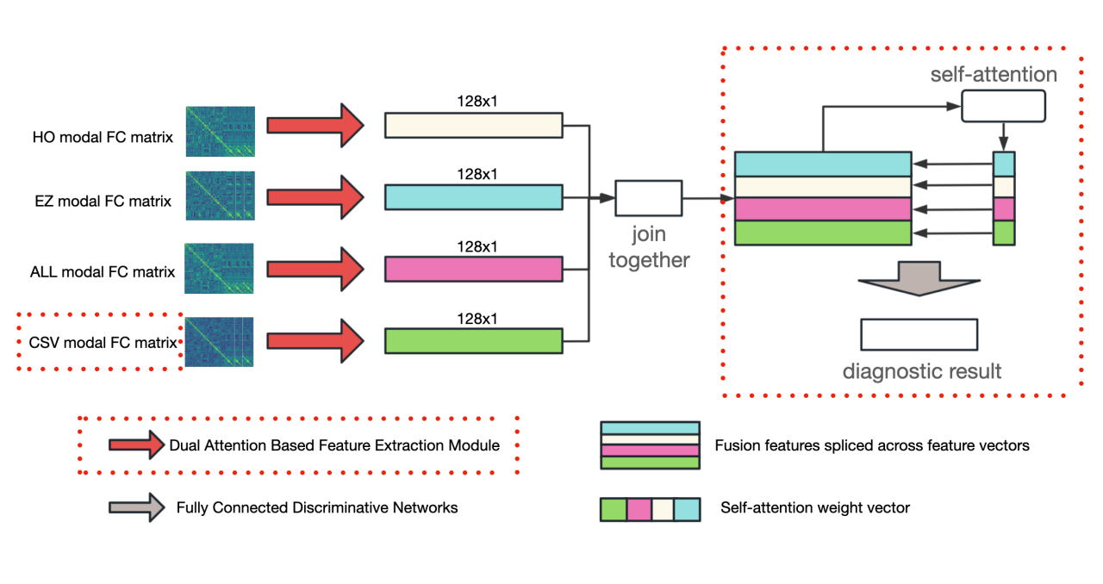

Figure 3-1 Schematic diagram of the feature extraction network model

**3.1 Feature extraction module based on channel attention and spatial attention**

**3.1.1 Lightweight fusion feature approach at the viewpoint level**

In the previous introduction to multimodal feature fusion strategies, this study explores a perspective-level based multimodal feature fusion strategy, which aims to combine feature information from different sources in order to obtain a more comprehensive and enriched representation of the information. In this study, the strategy is implemented based on the functional connectivity correlation matrices obtained from three predefined brain network templates - aal, ho, and ez - which are 116x116, 111x111, and 116x116 squares, respectively. Based on these inputs, a view-level feature fusion approach for early fusion was designed and implemented, whereby the correlation matrices of these three modalities are integrated into a single fusion matrix by simple summation at the pixel level, as shown in Figure 3-2.

The main advantage of this fusion strategy is its preservation of the integrity of the original information as well as its intuitive nature. By performing the summation operation at the pixel level, information from different datasets is successfully fused together, which further enhances the diversity and expressiveness of features. Compared to fusion approaches that introduce complex computational or network structures, this simple summation-based approach requires no additional computational burden and has low computational and storage costs, ensuring the lightweight nature of the integrated dataset. To verify the effectiveness of this feature fusion strategy, this paper trains and evaluates the integrated dataset and compares it with the benchmark method. The experimental results show that the use of this perspective-level based feature fusion approach can significantly improve the accuracy of the model with a small improvement in all other indicators, thus confirming the effectiveness and practicality of the strategy.

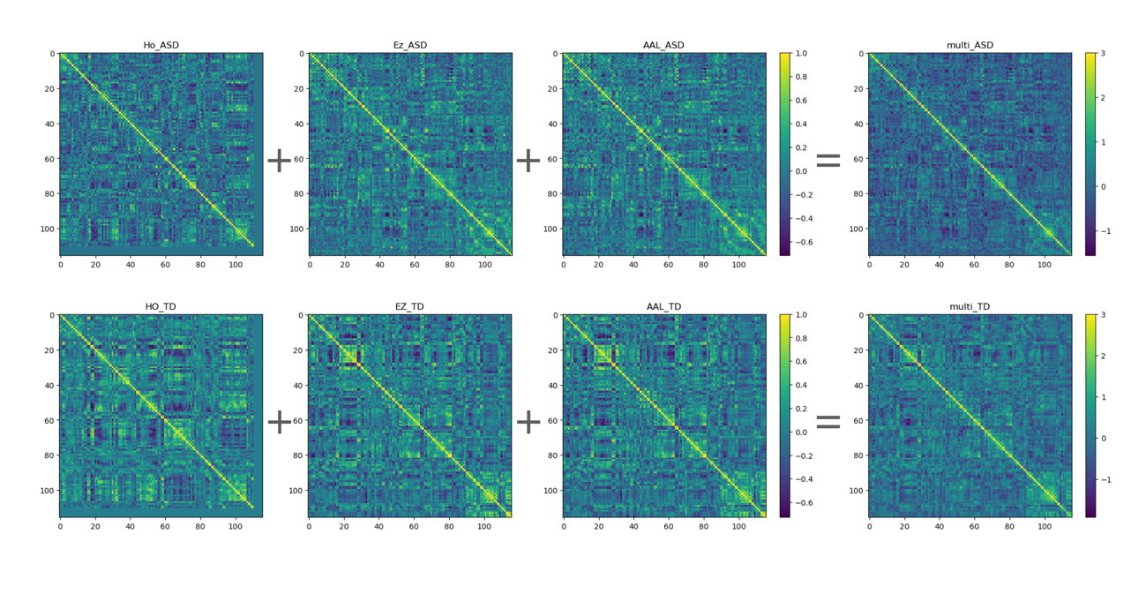

Figure 3 -2 Visualization of the correlation matrix between ASD individuals and TD individuals at the Caltech site

**3.1.2 Feature extraction module based on channel attention and spatial attention**

The feature extraction module is one of the core of the deep learning model designed in this study, and its main task is to extract features from the raw data that contribute to the task completion, and the tasks related to functional connectivity matrices often face a unique challenge. Unlike traditional images where neighboring pixels usually have similar colors or intensities, the pixel points in these matrices represent the correlations between two brain regions. As a result, pixel values do not have a continuous and correlated physical meaning. In addition, due to the limitation of the dataset size, some traditional deep learning models that are successful in vision tasks may not achieve effective results in this case. Therefore, selecting an appropriate feature extraction model becomes a critical step.

After extensively studying the related literature[49] , we found that most autism diagnostic methods commonly employ relatively simple techniques such as machine learning. This trend inspired us to try to build more lightweight feature extraction networks. Therefore, in this study, we chose a model based on the underlying convolutional neural network (CNN), and optimized and improved it. As shown in Figure 3-3, the feature extraction module contains two main parts: the convolutional layer and the attention mechanism.

First, initial feature extraction is performed on the input data using a convolutional neural network containing two convolutional layers and a fully connected layer. Each convolutional layer is followed by a maximum pooling layer to reduce the spatial size of the data and improve the abstraction capability of the model. Both layers of the convolutional network with processing power use a convolutional kernel of 3×3 size with a step size of 1 and a padding of 1 to ensure that the size of the output feature map is the same as the size of the original image. Immediately following the convolutional layer is the maximum pooling layer, which functions to perform downsampling to reduce the dimensionality of the features and improve the computational efficiency of the model.

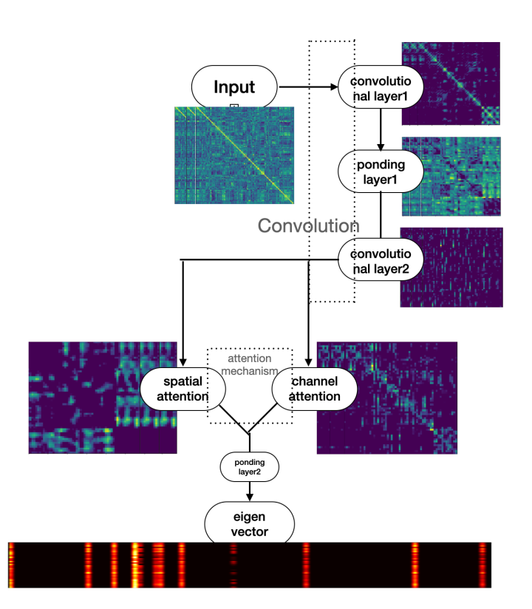

Figure 3-3 Schematic diagram of the feature extraction network model

Next, we introduced attention mechanisms for enhancing the model's attention to key features. Two attention mechanisms are used in this study: channel attention and spatial attention. Channel attention focuses on the channel dimensions of features, as shown in Figure 3-4. First, the spatial information of each channel is compressed using adaptive average pooling and maximum pooling. Then the features are processed by two 1x1 convolution operations and ReLU activation function to process the results of average pooling and maximum pooling, respectively, and these two sets of features are summed up. Finally, the weights of each channel are obtained by a sigmoid function to adjust each channel of the input features. Spatial attention focuses on the spatial distribution of the features, as shown in Figure 3-5. Two sets of features are obtained by calculating the mean and maximum values for each channel, which are then spliced in the channel dimension. Then this new set of features is processed by a convolution operation, and finally the weight of each position is obtained by a sigmoid function, which is used to adjust each position of the input features.

Spatial attention helps the model to better capture locally important features, allowing the model to focus on features in different regions, while channel attention emphasizes the global information of the features, allowing the model to extract and emphasize important features in a global context. The combination of these two attention mechanisms allows the model to take into account both local and global important information during feature extraction, which leads to better extraction of meaningful features and thus improves the performance of the model. In addition, the attention mechanism can make our model more robust to factors such as scale and location of the input data. The experimental results also corroborate the above advantages, and compared with the benchmark model, the dual-attention based feature extraction model can effectively improve the model's specificity and the probability of negative predictive value.

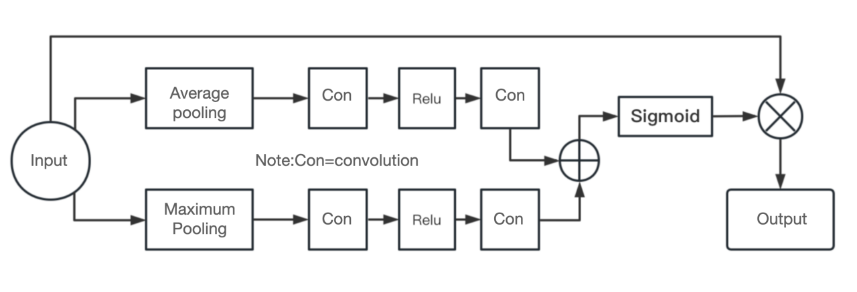

Figure 3-4 Channel Attention Network

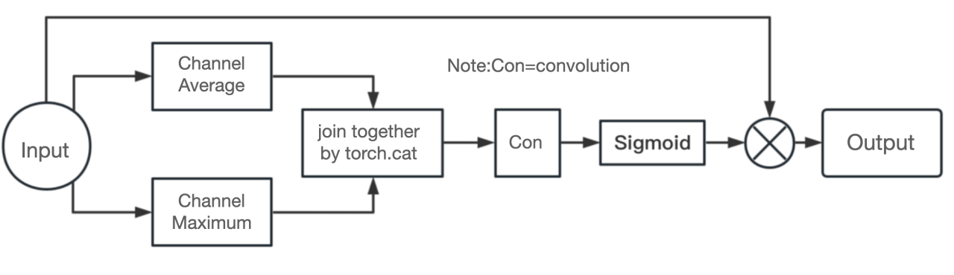

Figure 3-5 Spatial Attention Network

**3.2 Self-attention based feature fusion discrimination module**

After performing the feature extraction phase, we successfully obtained functional connectivity matrix features for four modalities (fusion matrix, HO, EZ, AAL). These features characterize the different brain networks of resting-state functional MRI, respectively. In order to utilize the respective advantages of these features more effectively in subsequent classification tasks, a feature fusion module based on the self-attention mechanism was designed in this study, as shown in Figs. 3-6.

First, the feature connection matrices of these four modalities are spliced in the channel direction. A new four-dimensional feature mapping is generated, where each dimension represents the batch size, the number of modalities, and the dimension of each modality feature mapping, respectively. Then, the dot product similarity between these feature mappings is calculated based on the above feature mappings and scaled by multiplying it by a scaling factor to ensure the stability of the gradient during training. This scaling factor is the negative square root of the feature dimension. The similarity matrix thus computed reflects the dependencies between the different modal functional connectivity matrices. By passing this similarity matrix through the Sigmoid function, the attentional weights of each modality at different positions are obtained. These weights are summed to obtain a vector representing the overall importance of each modality. This vector is again normalized by applying the Softmax function, and the final modal weights are obtained. Finally, we multiply the feature mapping of each modality by its corresponding weight and then sum it to obtain a functional connectivity matrix feature that incorporates information from multiple modalities. This combined feature will be fed into subsequent classifiers for the final autism diagnosis.

This self-attention based feature fusion module enables the model to adaptively weigh the degree of dependence on different modalities for more accurate classification decisions. It aims to mine and utilize the intrinsic correlations between modalities, as well as the unique information in different modalities. Moreover, it employs only simple mathematical operations in the fusion process to increase the robustness of the algorithm and reduce the likelihood of overfitting, as well as to skillfully ensure the stability of the data. This design allows our model to increase the interpretability of the diagnosis while effectively handling each modal eigenvector. With the modal weight vectors, researchers can obtain information about the importance of different modalities, providing a powerful tool for improving and understanding autism diagnosis.

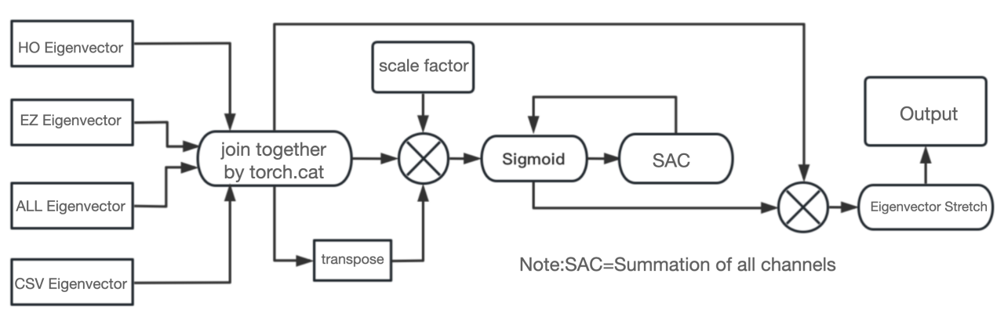

Figure 3-6 Self-attentive network

**3.3 Summary**

This chapter focuses on the autism prediction model proposed in this study. In the feature extraction part of the brain function matrix, we designed a view-level-based multimodal feature fusion method, which is based on three predefined brain network templates, aal, ho, and ez, and integrates the correlation matrices of the three modalities into a fusion matrix by simple summation at the pixel level to obtain a more comprehensive and rich information representation. To address the problem of how to extract features from the functional matrices that contribute to the diagnosis of autism, this study constructed a feature extraction module that relies on channel attention and spatial attention. This module utilizes a convolutional neural network (CNN) to extract attributes from each type of data and enhances the key features through the attention mechanism, thus improving the performance of the model. In the feature fusion part, this study designs a self-attention based feature fusion module. This module can dynamically adjust the importance of each modal feature to deeply explore the potential associations between modalities, realizing the complementary information between modalities, and thus providing more comprehensive information for the diagnosis of autism

**4 Experimental results and analysis**

**4.1 ABIDE data set**

The ABIDE (Autism Brain Imaging Data Exchange) dataset[50] is a large-scale neuroimaging dataset widely used in autism (ASD) research. The brain imaging data captured in this dataset, provided by several international research organizations, covers resting-state functional magnetic resonance imaging (rs-fMRI) and structural magnetic resonance imaging (sMRI) data from individuals with autism, as well as healthy controls (TCs). The goal of the study is to contribute to the updating and development of methods for analyzing neurophysiology, biomarkers, and imaging data in autism.All data in the ABIDE dataset remain anonymized and in compliance with laws and regulations, protecting the personal information of all participants.ABIDE provides a noncommercial data-sharing service to support all types of scientific research. The ABIDE I dataset used in this study, provided by 17 international research organizations, contained a total of 1,112 participants, of whom 539 were individuals with ASD and 573 were normal controls. The mean age of these participants was 14.7 years.The ABIDE dataset provides not only the scan data, but also the diagnostic criteria for autism, the scanning equipment model, the scanning parameter settings, and various phenotype files. These phenotype files detail important information such as participants' age, gender, diagnosis, intelligence quotient (IQ), Autism Observation Scale (ADOS) scores, and Autism Diagnostic Interview Scale (ADI-R) scores. Through ABIDE's official website, researchers can easily download these rs-fMRI data.

The Preprocessed Connectomes Project (PCP) is a collaborative project designed to provide researchers with preprocessed neuroimaging data for use in a variety of studies and analyses. The project focuses on functional magnetic resonance imaging (fMRI) data and provides a standardized preprocessing process to ensure consistency and comparability across datasets.

The diversity and complexity of the ABIDE dataset makes it a valuable resource for autism research. In order to make it more convenient for cross-disciplinary researchers to study autism, PCP's ABIDE Preprocessed project based on the analysis of the ABIDE I database[50] . The ABIDE Preprocessed project is a preprocessing project of the original ABIDE dataset, aiming to provide researchers with preprocessed data to further facilitate the study of autism. Based on the original ABIDE I dataset, the ABIDE Preprocessed project performs a series of preprocessing steps on the data, including motion correction, cuts, spatial normalization, and smoothing. In addition, it applies a variety of popular preprocessing procedures, such as Configurable Pipeline for the Analysis of Connectomes (CPAC), Data Processing Assistant for Resting-State fMRI (DPARSF), the fMRI of the Brain Software Library (FSL), and the Neuro Imaging Analysis Kit.A key feature of the ABIDE Preprocessed project is that it provides multiple preprocessed versions of the data to meet different research needs. For example, some researchers may need to apply a specific preprocessing process to meet their research goals, while others may wish to compare the effects of different preprocessing processes on their study results. This study used data from the ABIDE Preprocessed project that were filtered through a band-pass filter and processed using the DPARSF approach, as shown in Table 4-1. These preprocessed data provide an effective, convenient, and standardized fMRI data for our study, making the results generalizable and reproducible.

|  |  |  |  |  |  |  |
| --- | --- | --- | --- | --- | --- | --- |
| **Table 4-1 Overview of ABIDE data used in this study** | | | | | | |
| **website** | Whether or not they are autistic | | distinguishing between the sexes | | add up the total | Age range |
| be | clogged | male | women |
| **CALTECH1** | 5 | 10 | 10 | 5 | 15 | 17~56 |
| **CMU** | 6 | 5 | 7 | 4 | 11 | 19~33 |
| **KKI** | 12 | 21 | 24 | 9 | 33 | 8~13 |
| LEUVEN | 26 | 30 | 49 | 7 | 56 | 12~32 |
| NYU | 74 | 98 | 136 | 36 | 172 | 6~39 |
| OHSU | 12 | 13 | 25 | 0 | 25 | 8~15 |
| OLIN | 14 | 14 | 23 | 5 | 28 | 10~24 |
| SBL | 12 | 14 | 26 | 0 | 26 | 20~49 |
| SDSU | 8 | 19 | 21 | 6 | 27 | 9~17 |
| STANFORD | 12 | 13 | 18 | 7 | 25 | 8~13 |
| TRINITY | 19 | 25 | 44 | 0 | 44 | 12~26 |
| UCLA | 48 | 37 | 74 | 11 | 85 | 8~18 |
| UM | 47 | 73 | 93 | 27 | 120 | 8~29 |
| USM | 43 | 24 | 67 | 0 | 67 | 9~50 |
| YALE | 22 | 19 | 25 | 16 | 41 | 7~18 |
| (grand) total | 403 | 468 | 727 | 144 | 871 | 6~58 |

**4.2 Training methods and evaluation indicators**

To ensure the credibility and generalizability of the results, we used K-fold cross-validation to train and validate the model, and set K=5 according to the dataset.During the training process, we set the maximum number of iterations to be 100, the batch size to be 128, and chose Adam as the optimizer, with an initial learning rate of 0.001, and set up a learning rate decline strategy, which is specified as follows: after each 10th iterations, the learning rate will be decreased to 0.1 of the previous one to improve the accuracy and stability of the model in the later stages of training. Between each fold of training, the model uses the Kaiming approach to initialize the weights.

We choose the cross-entropy loss function as the optimization objective. The cross-entropy loss function has its advantages in dealing with binary classification problems: it not only measures the similarity between the probability distribution predicted by the model and the true distribution, but also better handles the problem of category imbalance, so it is widely used in classification tasks.

In the course of our prediction classification study, five key performance indicators were chosen to evaluate the prediction results, they are: Accuracy, which is a measure of the degree of correctness of the prediction results, in simple terms, it is the ratio of the number of correct predictions to the total number of predictions; sensitivity measures the number of correctly predicted positive case samples (i.e., samples that would have been positive cases and were correctly predicted), and the number of correctly predicted positive case samples. sensitivity measures the proportion of correctly predicted positive samples (i.e., samples that were positive and correctly predicted) among all true positive samples; specificity evaluates the proportion of correctly predicted negative samples (i.e., samples that were negative and correctly predicted) among all true negative samples; positive predictive value (PPV) indicates the proportion of samples that are truly positive among all samples predicted to be positive; and accordingly, the negative predictive value (PPV) indicates the proportion of samples that are truly positive; and accordingly, the negative predictive value (PPV) is the proportion of samples predicted to be positive among all samples predicted to be positive. , negative predictive value (NPV) indicates the proportion of samples that are truly negative cases out of all samples that are predicted to be negative cases.

In implementing these metrics, we categorized the predictions into four categories: true positives (TP), false negatives (FN), true negatives (TN), and false positives (FP). For example, in this study, TP represents that the sample actual and predicted results are both ASD; FN represents that the sample actual is ASD but the predicted result is TD; TN represents that the sample actual and predicted results are both TD; and FP represents that the sample actual is TD but the predicted result is ASD.

The specific formulas are as follows:

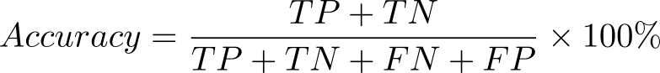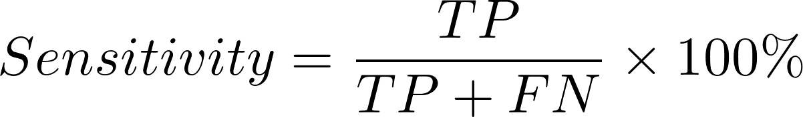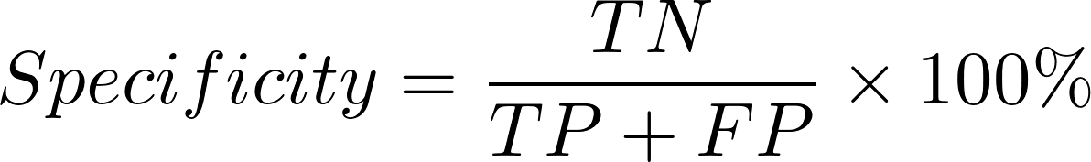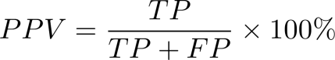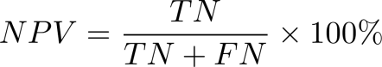

In addition, in order to comprehensively evaluate the performance of the model on the prediction of positive and negative samples, we incorporate the F1-score (F1-score) into the criterion.F1-score is a metric used for evaluating the performance of a binary classification model, which combines the precision and recall of the model.F1-score can be taken in the range of 0 to 1, and the higher the value means the better the performance of the model, which is computed as follows:

(4-6)

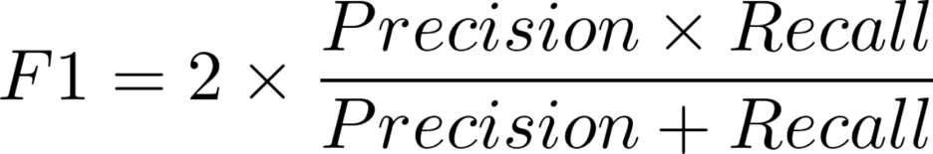

**4.3 Ablation experiments**

In this subsection, ablation experiments are conducted to validate the predictive performance of each of the perspective-level lightweight fusion feature approach, the channel-attention and spatial-attention-based feature extraction module, and the self-attention-based feature fusion discrimination module in the fusion feature's attentional classification model of functional brain connectivity in autism, and to analyze the contribution and impact of each module on each metric.

**4.3.1 Prediction performance of view-level feature fusion strategies**

In order to fuse the features of each brain network module while maintaining lightness, this study proposes a view-level feature fusion strategy by simple pixel summation, which is named CSV since the fusion result is saved in a .csv file.In order to demonstrate the effectiveness of this strategy, we compare, based on the base network (a bilayered CNN network without any attentional module), the performance metrics of the individual performance metrics of the unimodal versus the CSV approach.

|  |  |  |  |  |
| --- | --- | --- | --- | --- |
| **Table 4-3 F1 scores for each mode under the base network** | | | | |
|  | AAL | EZ | HO | CSV |
| **F1-score** | 0.5855 | 0.6990 | 0.6666 | **0.7010** |

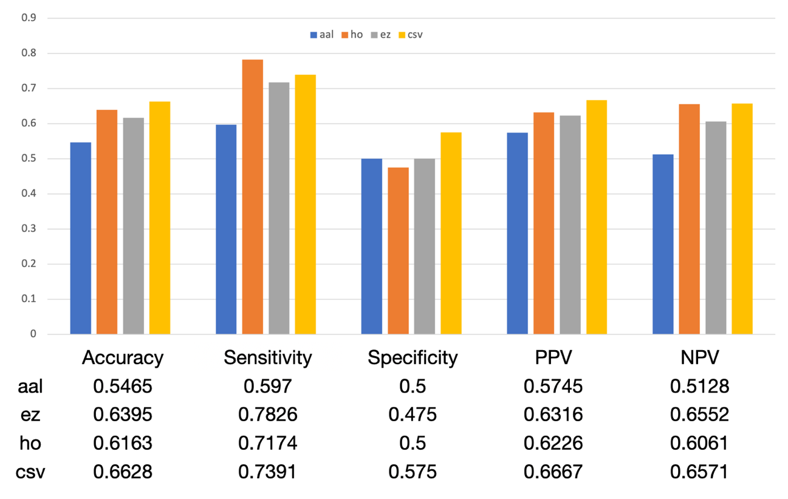

Figure 4-1 Histograms of Indicators

As shown in Figure 4-1, our proposed CSV fusion strategy demonstrated significant enhancement in all assessment metrics. In particular, the highest enhancements were observed in F1 score, accuracy, specificity, and positive predictive value, with maximum enhancements of up to 12%, 12%, 7%, and 9%, respectively. This result suggests that the CSV fusion strategy can effectively integrate the features of aal, ez, and ho brain functional connectivity modalities that are discriminative to ASD and TD, while suppressing the interference of redundant information to the model to a certain extent. Therefore, this strategy provides an effective means to improve the accuracy of autism recognition.

**4.3.2 Predictive Performance of Channel Attention and Spatial Attention Based Feature Extraction Modules**

In order to extract the features of the brain functional connectivity matrix more accurately, this study constructs a feature extraction module based on channel attention and spatial attention. A series of ablation experiments are designed in this part, aiming to analyze the contribution of the integrated attention module to the model performance and to further explore the effect of applying these two attention modules individually. In this way, we start from the underlying network and build the autism discriminator based on three different feature extraction strategies and then construct the autism discriminator. Causal inference based on the experimental results is performed in order to reveal the specific contribution and role of each module to the overall performance. We name the base network as CNN, while the CNN diagnostic models improved with single channel attention, single spatial attention and fusion attention as strategies are denoted as SCN (Single Channel Attention Network), SSA (Single Spatial Attention Network) and DAN ( Double Attention Network).

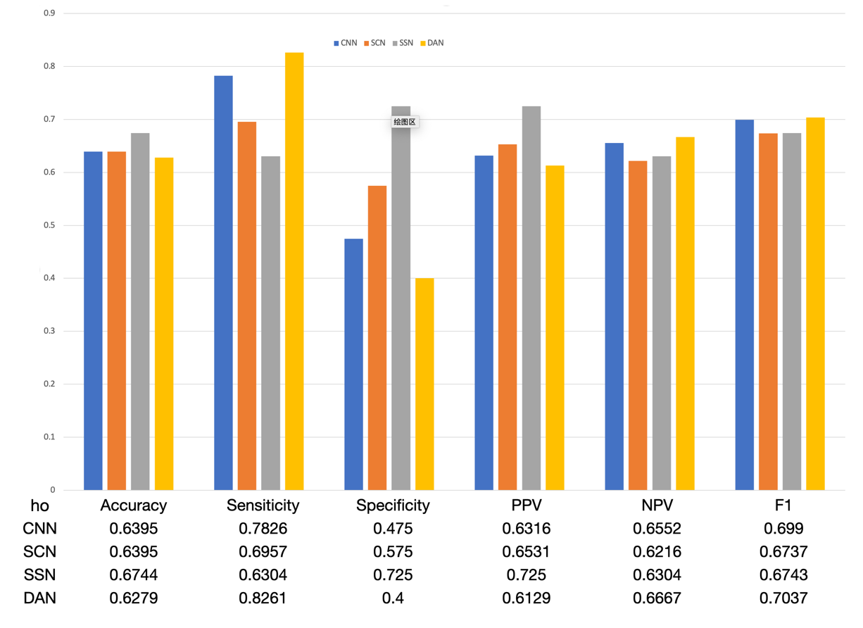

Figure 4 -2 Histogram of each model metric in ho mode

As the results presented in Figures 4-2 and 4-3, it can be observed that the introduction of DAN significantly improves the sensitivity of the model for the HO modality. This suggests that after spatial attention and channel attention have been introduced simultaneously, the model helps to improve the recognition of ASD by increasing the learning weights on ASD features. However, the side effect of this optimization strategy is a reduction in the ability to recognize TDs. In contrast, for the csv modality, the introduction of DAN significantly improves the specificity of the model, which suggests that after the introduction of both spatial attention and channel attention, the model improves the ability to recognize TD by increasing the learning weights on TD features. However, this again comes at the cost of a reduced ability to recognize ASD.

The above observations reveal the phenomenon that with the introduction of both spatial and channel attention, the model can autonomously learn the features of ASD or TD according to the unique characteristics of each modal data, thus improving the model's performance. This may be attributed to the fact that these attention mechanisms can help the model to focus on more discriminative features and thus exhibit higher accuracy in processing the corresponding samples.

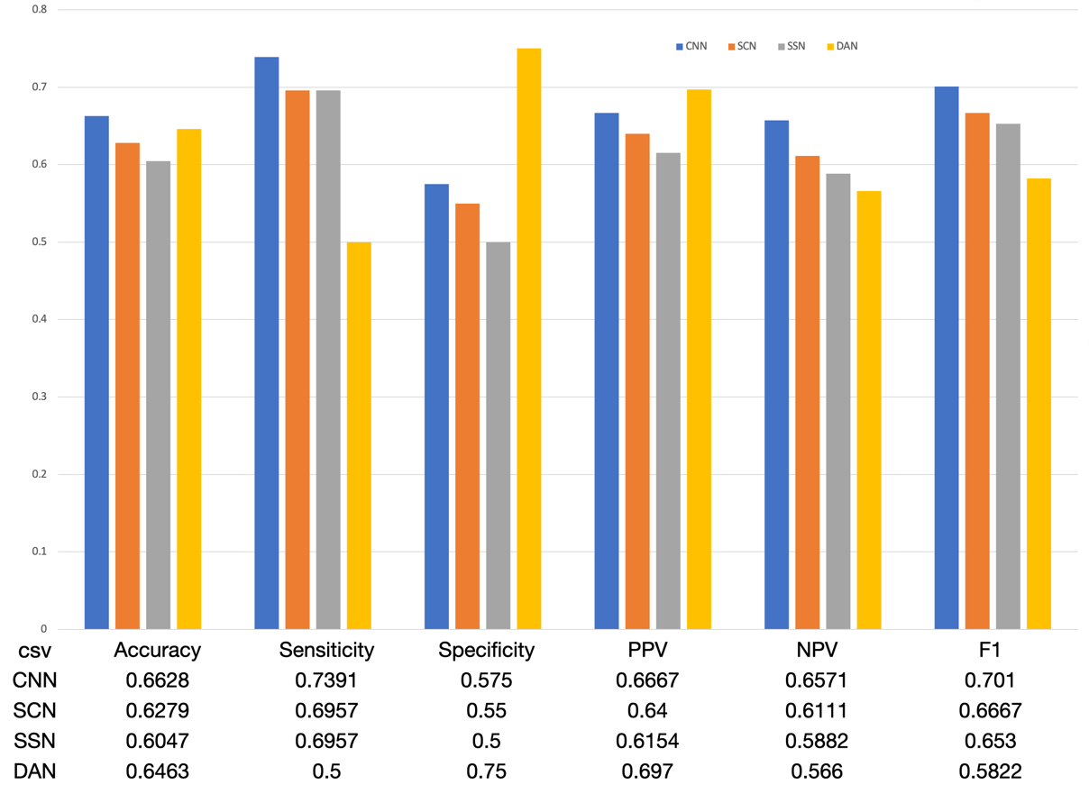

Figure 5 -3 Histograms of each model metric in csv mode

**4.3.3 Prediction Performance of Self-Attention Based Feature Fusion Discriminant Module**

In order to effectively utilize the features of brain functional connectivity matrices of different modalities and improve the diagnostic performance of the model, this study constructed a feature fusion discriminant module based on self-attention based on DAN and named it TAN (Three Attention Network).A series of ablation experiments were designed in this part, aiming to analyze the contribution of the self-attention module to the model performance. As a comparison, the network using a simple fully connected layer as the feature fusion discriminant module is named NAN (No Self Attention).The performance metrics of each fold of the 5-fold cross-validation of TAN are shown in Table 4-4, and the comparison between TAN and NSN is shown in Figure 4-4.

|  |  |  |  |  |  |
| --- | --- | --- | --- | --- | --- |
| Table 4-4 5-fold cross-validation results for TAN networks | | | | | |
|  | accuracy | sensitivity | specificity | ppv | npv |
| 1 fold | 0.6924 | 0.7226 | 0.6728 | 0.7522 | 0.6917 |
| **2 fold** | 0.7143 | 0.7487 | 0.6941 | 0.7721 | 0.7079 |
| **3 fold** | 0.7158 | 0.7522 | 0.6994 | 0.7766 | 0.6912 |
| **4 fold** | 0.7069 | 0.7453 | 0.6925 | 0.7697 | 0.6973 |
| **5 fold** | 0.7181 | 0.7525 | 0.6987 | 0.7779 | 0.7054 |
| **average** | **0.7095** | **0.74426** | **0.6915** | **0.7697** | **0.6967** |

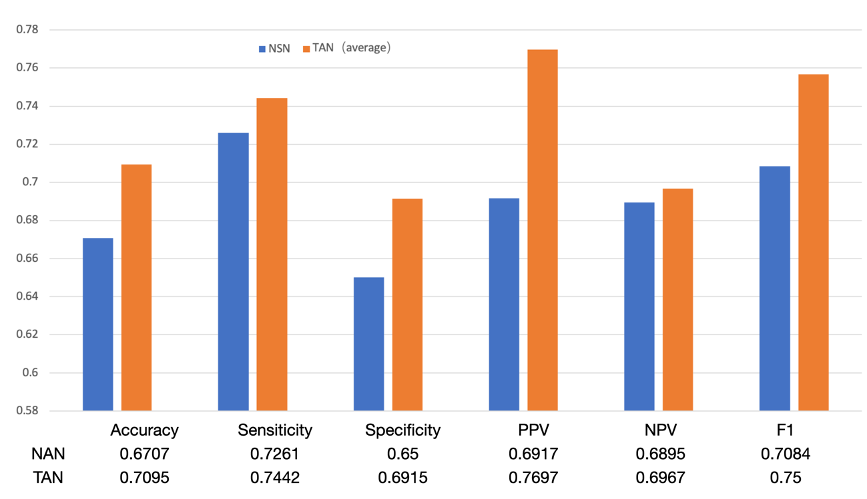

Figure 6 -4 Comparison of TAN and NAN for various performance metrics

Figure 4-4 clearly demonstrates the enhancement of the model's performance metrics by the addition of the self-attention mechanism, with the enhancement of the positive predictive value, the negative predictive value, and the F1 score being particularly significant. This result indicates that the self-attention mechanism can effectively fuse the features of different modalities. Based on the previous analysis, this paper tries to provide an explanation for how the model operates: the model extracts features with ASD or TD specificity and feeds them into the feature fusion module by means of the channel-attention and spatial-attention based feature extraction module. Then, the self-attention based feature fusion discrimination module organically organizes these features together, which ultimately leads to a significant improvement in the overall performance of the model.

**4.4 Comparative experiments**

The structure of the algorithm proposed in this paper is compared with the results of five machine learning or deep learning based autism diagnosis of approximate size in the ABIDE dataset study, as shown in Tables 4-5. The models Hi-GCN[51] and VIT-B/16[19] adopt the graph network technique based on the construction of AAL templates and the transformer technique based on the ROI time series augmentation of data volume, respectively, which require a priori knowledge of the brain and nerves, and have a high demand on the researcher's medical background knowledge, and may be affected by the researcher's subjective factors in designing the network structure and selecting the features, and may have the potential to be influenced by the researcher's subjective factors. The design of the network structure and selection of features may be affected by the researcher's subjective factors and may have problems such as poor robustness. However, as shown in Tables 4-5, the lightweight approach proposed in this study still has advantages in terms of sensitivity, although compared with these a priori networks. As for the conventional network[52][53][54] , which does not require prior knowledge, the fused modal approach proposed in this study shows different degrees of superiority in all performance analysis metrics. All these results fully confirm the effectiveness and superiority of our research method.

|  |  |  |  |  |  |  |
| --- | --- | --- | --- | --- | --- | --- |
| Table 4-5 Comparison of this paper's method with other methods | | | | | | |
| Does the method require a priori knowledge | reticulation | Data modal (predefined templates) | Accuracy (%) | Sensitivity (%) | Specificity (%) |
| a priori (philosophy) | Hi-GCN[51] | AAL | 72.81 | 72.04 | 73.91 |
| VIT-B/16[19] | AAL | **76.69** | 74.18 | 72.91 |
| a priori (philosophy) | MC-NFE[52] | BASC | 68.42 | 70.05 | 63.34 |
| DNN[53] | CC200 | 70 | 74 | 63 |
| SVM[54] | MSDL | 67.90 | 58.10 | **76.60** |
| CNN[56] | RSNs | 65.30 | **---** | --- |
| our-model | Multi-mode | 70.95 | **74.42** | 69.15 |

**4.5 Summary of the chapter**

This chapter begins with a brief description of the ABIDE dataset used in this study. Next, the metrics used to assess the model's classification efficacy are described in detail and explained. Then, ablation experiments were conducted on each functional module of the model, and based on the results of the experiments, an explanation of how the model operates was proposed, i.e., the model first extracts the idiosyncratic features through the channel attention and spatial attention modules, and then fuses the idiosyncratic features through the self-attention module for discrimination. Finally, we compare the algorithmic structure proposed in this study with the results of five machine learning or deep learning based autism diagnosis with similar dataset sizes. The experimental results demonstrate that the algorithm proposed in this study exhibits excellent performance in all metrics in the lightweight modeling domain. Even in the domain of complex models that require prior knowledge, the algorithm in this study shows some advantages in terms of sensitivity.

**5 Summary and outlook**

**5.1 Full text summary**

In this paper, against the backdrop of the urgent need for automated autism diagnosis in the current clinical field, we launch an in-depth discussion on the cost and accuracy of different modality diagnosis methods, and then analyze the advantages and disadvantages of the existing machine learning and deep learning based autism diagnosis methods, and accordingly derive the method proposed in this study. Further, ablation experiments are designed in this study to reveal an explanation for implementing the algorithm. Finally, the accuracy of the proposed algorithm is verified through comparison experiments.

The process of the multimodal classification task consists of three main steps: (1) feature extraction of samples from multiple modalities; (2) fusion of the feature information of each modality to obtain a joint representation; and (3) use of the obtained fused features to train a classifier and obtain classification results. For these three aspects, the following optimization strategies are proposed in this study:

(1) Feature extraction: this study uses spatial attention to help capture locally important features so that the model can focus on features in different regions. At the same time, the global information of features is collected through channel attention, which enables the model to extract and emphasize important features in the global context. The combination of these two attention mechanisms allows the model to take into account both local and global important information during feature extraction, so that meaningful features can be extracted more efficiently and the performance of the model can be further improved.

(2) Feature fusion: this study proposes a lightweight feature fusion method, i.e., information from different modalities is fused together by performing a summing operation at the pixel level to enhance the diversity and expressiveness of features.

(3) Classifier Training and Result Acquisition: In this study, a self-attention based feature fusion module is designed. The self-attention mechanism can help the model adaptively weigh the degree of dependence on different modalities to make more accurate classification decisions.

**5.2 Prospects for work**

The clinical significance of autism diagnostic research is to be able to automate the process of assisting clinicians to diagnose individuals with autism in early infant and toddler populations for further treatment and intervention. The aim of this study is to propose a fused modality approach to autism diagnosis by using the feature fusion of three functional linking modalities, aal, ho and ez, as an example, and to validate the effectiveness of this fused modality idea in the field of autism diagnosis. Therefore, in the actual clinical diagnosis process, the resting-state MRI of infants and children can be analyzed using multiple predefined templates and used as the basis for comprehensive judgment.

In addition, the feature extraction network used in this paper is only improved based on a simple two-layer CNN network. If the researcher has some knowledge of brain neuroscience, he/she can try to construct graph networks based on the functional properties of different predefined templates for comprehensive analysis, which is expected to achieve better results. In addition, since the ABIDE I database only contains 1112 samples, it is difficult to support the training of neural networks with a large number of participants. To address this problem, Wenhui Li [19] tried to expand the data volume from 871 to 5779 based on the structure of ROI time series. This method of expanding the data by utilizing the brain neural knowledge provides a new possibility for autism diagnosis to break through the barrier of limited dataset.

**A Thank-you Note**

First of all, I would like to thank my supervisor, Prof. Yu Li. In the research work, Ms. Yu was serious and responsible, and when I was hesitant to choose a topic for my thesis, she guided me to choose the topic of autism diagnosis according to my own interests, and gave me a lot of effective advice on research methods. In the usual communication, Ms. Yu is easy to approach, patiently answering my confusion about the choice of profession and the direction of life, every time after communicating with Ms. Yu Li, the confusion, anxiety and uneasiness in my heart can always be dissipated.

Next, I would like to thank Ms. Lin Xian in the lab. In the process of doing my graduation design, my sister gave me a lot of help, not only in the revision of the thesis content, but also in the thesis ideas to give me a lot of inspiration, in addition to the experimental methods patiently guided me, so that I benefited a lot.

Finally, I would like to thank my parents and my girlfriend. Thank you for your support and understanding, and for giving me support and encouragement at such a frustrating time of loss when I was pushing the wrong approach to start over because of the delayed progress of my experiments.

**Reference**

[1]段云峰,吴晓丽,金锋.自闭症的病因和治疗方法研究进展[J].中国科学:生命科学,2015,45(09):820-844.

[2]杨文峰.自闭症儿童的社会缺陷及其早期干预研究[J].大家健康(学术 版),2014,8(18):171.

[3]王露,陈小梅,冯建新.儿童自闭症评定量表的发展演变及应用[J].现代特殊教育,2021,No.411(12):74-80.

[4]Yamada, T., Hashimoto, R. I., Yahata, N., Ichikawa, N., Yoshihara, Y., Okamoto, Y., ... & Kawato, M. (2017). Resting-state functional connectivity-based biomarkers and functional MRI-based neurofeed- back for psychiatric disorders: a challenge for developing theranostic biomarkers. International Journal of Neuropsychopharmacology, 20(10), 769-781.

[5]Anderson, J. S., Nielsen, J. A., Froehlich, A. L., DuBray, M. B., Druzgal, T. J., Cariello, A. N., ... & Alexander, A. L. (2011). Functional connectivity magnetic resonance imaging classification of autism. Brain, 134(12), 3742-3754.

[6]Belmonte, M. K., Allen, G., Beckel-Mitchener, A., Boulanger, L. M., Carper, R. A., & Webb, S. J. (2004). Autism and abnormal development of brain connectivity. Journal of Neuroscience, 24(42), 9228-9231.

[7]Just, M. A., Cherkassky, V. L., Keller, T. A., & Minshew, N. J. (2004). Cortical activation and synchronization during sentence comprehension in high-functioning autism: evidence of underconnectivity. Brain, 127(8), 1811-1821.

[8]Mller, R. A., Shih, P., Keehn, B., Deyoe, J. R., Leyden, K. M., & Shukla, D. K. (2011). Underconnected, but how? A survey of functional connectivity MRI studies in autism spectrum disorders. Cerebral cortex, 21(10), 2233-2243.

[9]Martino A D, Yan C G, Li Q, et al. The autism brain imaging data exchange: towards large-scale evaluation of the intrinsic brain architecture in autism [J]. Molecular Psychiatry, 2014, 19(6): 659-667.

[10]邓明昱, 劳世艳. 自闭症谱系障碍的临床研究新进展(DSM-5新标准)[J]. 中国健康心 理学杂志, 2016, 24(4): 481-490.

[11]张静.DSM-V自闭症诊断标准的应用价值及争议[J].现代特殊教育,2015,No.261(06):40-44.

[12] Parkhi, Omkar M., Andrea V edaldi, and Andrew Zisserman. "Deep face recognition." (2015).

[13] Joshua Samuel Raj, R., et al. "A GAN-Based Triplet FaceNet Detection Algorithm Using Deep Face Recognition for Autism Child." Disruptive Technologies for Big Data and Cloud Applications: Proceedings of ICBDCC 2021. Singapore: Springer Nature Singapore, 2022. 177-187.

[14]Li, Beibin, et al. "A facial affect analysis system for autism spectrum disorder." 2019 IEEE International Conference on Image Processing (ICIP). IEEE,

[15]Eunji Chong et al. Detecting Gaze Towards Eyes in Natural Social Interactions and Its Use in Child Assessment[J]. Proceedings of the ACM on Interactive, Mobile, Wearable and Ubiquitous Technologies, 2017, 1(3) : 1-20.

[16]Hazlett Heather Cody et al. Early brain development in infants at high risk for autism spectrum disorder.[J]. Nature, 2017, 542(7641) : 348-351.

[17]Nur, Alisa Ali. "Autism spectrum disorder classification on electroencephalogram signal using deep learning algorithm." IAES International Journal of Artificial Intelligence 9.1 (2020): 91.

[18]Emerson,R.W.,Adams,C.,Nishino,T.,Hazlett,H.C.,Wolff,J.J.,Zwaigenbaum,L.,…Piven,J.(2017).Functional neuroimaging of high-risk 6-month-old infants predicts a diagnosis of autism at 24 months of age.Science Translational Medicine,9(393),eaag2882.doi:10.1126/scitranslmed.aag2882

[19]W. Li, S. Wang and G. Liu, "Transformer-based Model for fMRI Data: ABIDE Results," *2022 7th International Conference on Computer and Communication Systems (ICCCS)*, Wuhan, China, 2022, pp. 162-167, doi: 10.1109/ICCCS55155.2022.9845999.

[20]Xin Yang, Ning Zhang, Paul Schrader,A study of brain networks for autism spectrum disorder classification using resting-state functional connectivity,Machine Learning with Applications, Volume 8,2022,100290,ISSN 2666-8270,<https://doi.org/10.1016/j.mlwa.2022.100290>.

[21]Hewson-Stoate N, Jones M, Martindale J, et al. Further nonlinearities in neurovascular coupling in rodent barrel cortex [J. Neuroimage, 2005, 24(2): 565 ~ 574.

[22]Scarapicchia V. Resting state BOLD variability in Alzheimer's Disease: A marker of cognitive decline or cerebrovascular status?[J]. Frontiers in Aging Neuroscience, 2018, 10: 39~46.

[23]Biswal B, Yetkin F Z, Haughton V M, et al. Functional connectivity in the motor cortex of resting human brain using echo-planar MRI[J. Magnetic Resonance in Medicine, 1995, 34(4):537~541.

[24]Raichle M E. Two views of brain function U]. Trends in Cognitive Sciences, 2010, 14（4):180~190.

[25]Gorrostieta C, Ombao H, Bedard P, et al. Investigating brain connectivity using mixed effects vector autore gressive models[JJ. Neuroimage, 2012, 59(4):3347- 3355.

[26]Z Friston K J. Functional and effective connectivity in neuroimaging: a synthesis. Hum Brain Mapp[Jl, 1994, 2:56-~ 62.

[27]Cordes D, Haughton V M, Arfanakis K, et al. Mapping functionally related regions of brain with functional connectivity MR imaging [J]. American Journal of Neuroradiology, 2000, 21(9): 1636~ 1644.

[28]Salvador R, Suckling J, Coleman M R, et al. Neurophysiological architecture of functional magnetic resonance images of human brain [J. Cerebral Cortex, 2005, 15(9): 1332~ 1342.

[29]Tourio-Mazoyer N, Landeau B, Papathanassiou D, et al. Automated anatomical labeling of activations in SPM using a macroscopic anatomical parcellation of the MI MRI single-subject brain[J]. Neuroimage, 2002, 15(1):273~289.

[30]Martijn P. van den Heuvel, Hilleke E. Hulshoff Pol,Exploring the brain network: A review on resting-state fMRI functional connectivity,European Neuropsychopharmacology,Volume 20, Issue 8,2010,Pages 519-534,ISSN 0924-977X, <https://doi.org/10.1016/j.euroneuro.2010.03.008>.

[31]S. Albawi, T. A. Mohammed and S. Al-Zawi, "Understanding of a convolutional neural network," *2017 International Conference on Engineering and Technology (ICET)*, Antalya, Turkey, 2017, pp. 1-6, doi: 10.1109/ICEngTechnol.2017.8308186.

[32]LeCun, Yann, and Yoshua Bengio. "Convolutional networks for images, speech, and time series." *The handbook of brain theory and neural networks* 3361.10 (1995): 1995.

[33]LeCun Y, Bottou L, Bengio Y, et al. Gradient-based learning applied to document recognition [C].Proceedings of the IEEE. 1998. 86(11): 2278-2324.

[34]Krizhevsky A. Sutskever I, Hinton G. ImageNet Classification with Deep Convolutional Neural Networks [J. Advances in neural information processing systems, 2012, 25(2).

[35]Simonyan K, Zisserman A. Very Deep Convolutional Networks for Large-Scale Image Recognition[J/OL]. arXiv: 1409.1556.

[36]He K, Zhang X, Ren S. et al. Deep Residual Learning for Image Recognition [C]. Proceedings of IEEE Conference on Computer Vision and Pattern Recognition, 2016: 27-30.

[37]Alom M Z, Hasan M, Yakopcic C, el al. Improved Inception-Residual Convolutional Neural Network for Object Recognition [J. Neural Computing and Applications, 2020, 32(1): 279-293.

[38]Jaderberg, Max, Karen Simonyan, and Andrew Zisserman. "Spatial transformer networks." *Advances in neural information processing systems* 28 (2015).

[39]Hu, Jie, Li Shen, and Gang Sun. "Squeeze-and-excitation networks." *Proceedings of the IEEE conference on computer vision and pattern recognition*. 2018.

[40]Zhang C, Yang Z, He X, et al. Multimodal intelligence: Representation learning, information fusion, and applications[J]. IEEE Journal of Selected Topics in Signal Processing, 2020, 14(3): 478-493.

[41]Chen T, Ma X, Liu X, et al. Multi-view learning with feature level fusion for cervical dysplasia diagnosis[C]//International Conference on Medical Image Computing and Computer-Assisted Intervention. Springer, Cham, 2019: 329-338.

[42]Guo Z, Li X, Huang H, et al. Medical image segmentation based on multi-modal convolutional neural network: Study on image fusion schemes[C]//2018 IEEE 15th International Symposium on Biomedical Imaging (ISBI 2018). IEEE, 2018: 903-907.

[43]Zhou T, Fu H, Zhang Y, et al. M2Net: Multi-modal Multi-channel Network for Overall Survival Time Prediction of Brain Tumor Patients[J]. arXiv preprint arXiv:2006.10135, 2020.

[44]Nojavanasghari B, Gopinath D, Koushik J, et al. Deep multimodal fusion for persuasiveness prediction[C]//Proceedings of the 18th ACM International Conference on Multimodal Interaction. 2016: 284-288.

[45]Xu T, Zhang H, Huang X, et al. Multimodal deep learning for cervical dysplasia diagnosis[C]//International conference on medical image computing and computer-assisted intervention. Springer, Cham, 2016: 115-123.

[46]Duanmu H, Huang P B, Brahmavar S, et al. Prediction of Pathological Complete Response to Neoadjuvant Chemotherapy in Breast Cancer Using Deep Learning with Integrative Imaging, Molecular and Demographic Data[C]//International Conference on Medical Image Computing and Computer-Assisted Intervention. Springer, Cham,2020: 242-252.

[47]Yu Z, Yu J, Fan J, et al. Multi-modal factorized bilinear pooling with co-attention learning for visual question answering[C]//Proceedings of the IEEE international conference on computer vision. 2017: 1821-1830.

[48]Yang Z, He X, Gao J, et al. Stacked attention networks for image question answering[C]//Proceedings of the IEEE conference on computer vision and pattern recognition. 2016: 21-29.

[49]Yang, Xin, Ning Zhang, and Paul Schrader. "A study of brain networks for autism spectrum disorder classification using resting-state functional connectivity." *Machine Learning with Applications* 8 (2022): 100290.

Craddock, Cameron, et al. "The neuro bureau preprocessing initiative: open sharing of preprocessed neuroimaging data and derivatives." *Frontiers in Neuroinformatics* 7 (2013): 27.

[50]Jiang, Hao, et al. "Hi-GCN: A hierarchical graph convolution network for graph embedding learning of brain network and brain disorders prediction." *Computers in Biology and Medicine* 127 (2020): 104096.

[51]Huang, Zhi-An, et al. "Identifying autism spectrum disorder from resting-state fMRI using deep belief network." *IEEE Transactions on neural networks and learning systems* 32.7 (2020): 2847-2861.

[52]Heinsfeld, Anibal Sólon, et al. "Identification of autism spectrum disorder using deep learning and the ABIDE dataset." *NeuroImage: Clinical* 17 (2018): 16-23.

[53]Abraham, Alexandre, et al. "Deriving reproducible biomarkers from multi-site resting-state data: An Autism-based example." *NeuroImage* 147 (2017): 736-745.

[54]Stone J A, Howard L P. A simple technique for observing periodic nonlinearities in Michelson interferometers. Precision Engineering,1998,22(4):220-232

[55] Bera, Asish, et al. "Attend and guide (ag-net): A keypoints-driven attention-based deep network for image recognition." *IEEE Transactions on Image Processing* 30 (2021): 3691-3704.

[56] Yao, Dongren, et al. "Triplet graph convolutional network for multi-scale analysis of functional connectivity using functional MRI." *Graph Learning in Medical Imaging: First International Workshop, GLMI 2019, Held in Conjunction with MICCAI 2019, Shenzhen, China, October 17, 2019, Proceedings 1*. Springer International Publishing, 2019.